

UNIVERSITY OF TORONTO

INSTITUTE FOR AEROSPACE STUDIES

4925 Dufferin Street, Toronto, Ontario, Canada, M3H 5T6

Dowel Packager Device

*prepared by*

**Team 62 – Wednesday**

Shafquat Arefeen (998980786)

Zexuan Wang (998851773)

Yiming Kang (998676730)

prepared for

Prof. M.R. Emami

A technical report submitted for

AER201 – Engineering Design

TA: Justin Girard

April 15, 2013

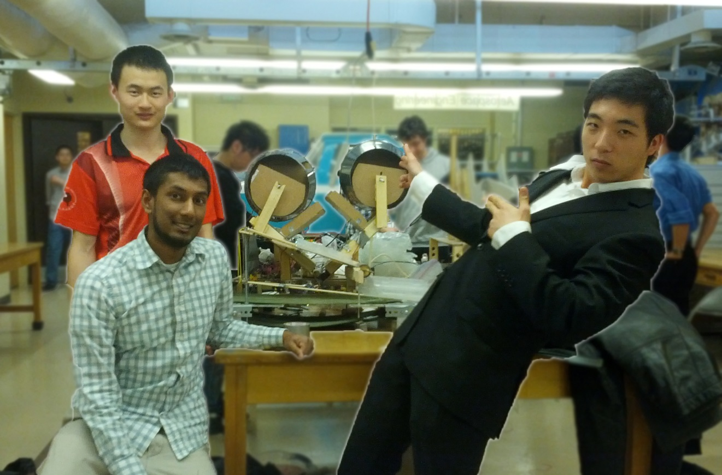

Dowel Packager Device

“The Brobot”

*prepared by*

**Team 62 – Wednesday**

Shafquat Arefeen (998980786)

Zexuan Wang (998851773)

Yiming Kang (998676730)

A technical report submitted for

AER201 – Engineering Design

TA: Justin Girard

April 15, 2013

Acknowledgements

Throughout the duration of the project we have received support and assistance from many individuals. Team 62 would like to acknowledge the help of:

AER201 Course Instructor M. Reza Emami

TAs Justin Girard and Victor Ragusila

Shop Supervisor Charles Lin

And all the other AER201 TAs

In addition we appreciate the assistance of our EngSci peers for their help both physically and conceptually.

Table of Contents

[1 Introduction 7](#_Toc353796129)

[1.1 - Background 7](#_Toc353796130)

[1.2 - Motivation 7](#_Toc353796131)

[2 Perspective and Objectives 7](#_Toc353796132)

[2.1 Design Parameters 7](#_Toc353796133)

[2.2 Project Theory/Concept (Division of the Problem) 8](#_Toc353796134)

[2.3 Acceptance Criteria in Decision Making (AHP Analysis) 9](#_Toc353796135)

[2.4 Budget 10](#_Toc353796136)

[3 Assessment of Problem (Perspective/Restrictions) 12](#_Toc353796137)

[4 Subsystems 12](#_Toc353796138)

[4.1 – Electromechanical System 12](#_Toc353796139)

[4.1.1 Assessment of the Problem 12](#_Toc353796140)

[4.1.2 Solution 13](#_Toc353796141)

[4.1.3 Suggestions for Improvement of the Subsystem 18](#_Toc353796142)

[4.2 Circuits 20](#_Toc353796143)

[4.2.1 Assessment of the Problem 20](#_Toc353796144)

[4.2.2 Solution 21](#_Toc353796145)

[4.2.3 Simulation Results 34](#_Toc353796146)

[4.2.4 Current Calculations 35](#_Toc353796147)

[4.2.5 Power Calculations 35](#_Toc353796148)

[4.2.6 Suggestions for Improvement of the Subsystem 35](#_Toc353796149)

[4.3 PIC Microcontroller 36](#_Toc353796150)

[4.3.1 Assessment of Problem 36](#_Toc353796151)

[4.3.2 Programming Solutions 37](#_Toc353796152)

[4.3.3 Suggestions for Improvement of the Subsystem 47](#_Toc353796153)

[5 Integration 48](#_Toc353796154)

[5.1 Integrate individual actuators with PIC controller 48](#_Toc353796155)

[5.2 Integrate sensors and transducer values with PIC controller 48](#_Toc353796156)

[5.3 Fixation of actuators and transducers 49](#_Toc353796157)

[5.4 Fixation of circuit boards and PIC controller 52](#_Toc353796158)

[6 Accomplished Schedule 54](#_Toc353796159)

[7 System Improvement Suggestions 56](#_Toc353796160)

[8 Description of Overall Machine 56](#_Toc353796161)

[9 Standard Operating Procedure 57](#_Toc353796162)

[10 Conclusion 57](#_Toc353796163)

[11 References and Bibliography 58](#_Toc353796164)

[Works Cited 58](#_Toc353796165)

Abstract

The problem was to package dowels of different colours in boxes within budget constraints. The solution was a machine that would feed in dowels into sorters to orient them and then put them into reservoirs. Once in the reservoirs the dowels would be packed into a moving box on a conveyor belt. The machine was to sort at least 12 dowels of each colour into 2 boxes in less than 2 minutes. It ran approximately 90% of the time with 7 or less dowels. There were issues in terms of sorting that made the problem much tougher and led to failure of the machine. This aspect of the machine could be improved with further time and resources. In light of this, the machine was reasonably successful which reaches most objects given. Optimizing the sorter would be the Achilles’ heel of the project.

Abbreviations

AHP: Analytical hierarchal process

PERT: Program evaluation and review technique

AC: Alternate current

DC: Direct current

LED: Light-emitting diode

LCD: Liquid crystal display

IR: Infrared

IC: Integrated circuit

PIC: Peripheral interface controller

PCB: Printed circuit board

I2C: Inter-integrated circuit

FSM: Finite state machine

EEPROM: Electrically erasable programmable read-only memory

RTC: Real time clock

CMOS: Complementary metal oxide semiconductor

BJT: Bipolar junction transistor

NPN: Negative-positive-negative (transistor)

PNP: Positive-negative-positive (transistor)

PWM: pulse width modulation

ISR: Interrupt service routine

A: amperes

V: volts

# 1 Introduction

## 1.1 - Background

The goal is to design and build a prototype for a machine that packages two different types of coloured dowels with respect to the user input selection. The machine is required to package two boxes that fit six cylindrical dowels. The device is required to sort the dowels after they are inputted in random orientation. Manual sorting of dowels and packaging are tedious and expensive for companies due to the manual labour that requires little skill. Therefore an autonomous robot that can do both these tasks in a reasonable time frame is needed to increase efficiency.

## 1.2 - Motivation

The company desires a fully automatic machine that can fit at least 3 boxes and 12 dowels in each reservoir. In addition the machine should be able to return values of dowels in each reservoir. Motivation for this machine is to create a more efficient system to reduce the amount of menial manual labour.

# 2 Perspective and Objectives

## 2.1 Design Parameters

The machine must be with regards to the AER201 Textbook [[1](#Ema13)]:

Compact in size

·         Be no larger than 75 cm x 75 cm x 75 cm

·         Weigh less than 6 kg

Cost Effective

·         Prototype costs should not exceed $230 CDN

Safe

·         Have an easily-accessible emergency STOP switch that stops all mechanical parts immediately

·         Structurally stable

·         Not pose any hazard to operator

Autonomous

·         No interaction with external devices

·         Operation must start after <start> button on keypad is pressed

·         No additional installation or instrumentation

·         Maximum 2 minute run time

Accurate

·         Operation time and remaining dowels should be prompted after completion

·         Each box should be packaged correctly to user input

User Friendly

·         Self-explanatory interface

## 2.2 Project Theory/Concept (Division of the Problem)

Description of Machine

The first important concept is the orientation of the dowels. In order to package the dowels into the box, they are required to be in the same orientation to ensure simplicity when packing. After packing, the closed box containing dowels is required to be dropped off in the pickup area.

The dowel packing machine can be brown down into 5 distinct steps:

1      Dowel-aligning (sorting)

2      Box loading

3      Dowel loading

4      Pattern selection and packing

5      Box unloading and lid-closing/locking

Mechanisms for accomplishing each of the five tasks are then considered separately. System integration is then needed to produce desired result.

## 2.3 Acceptance Criteria in Decision Making (AHP Analysis)

With reference to the Pugh chart created in the Design Proposal and amendments made throughout the semester, an AHP tree was created to show the criteria, alternative designs, and methods and their rank to the major design decision making on the dowel sorter to justify our appeal for the major design change on Apr.6.(Appendix O) This was done by decomposing the problem, weighing each individual criterion, evaluating them by comparison, and finally selecting the best fit for the requirements [[2](#BPM13)].

AHP Calculations:

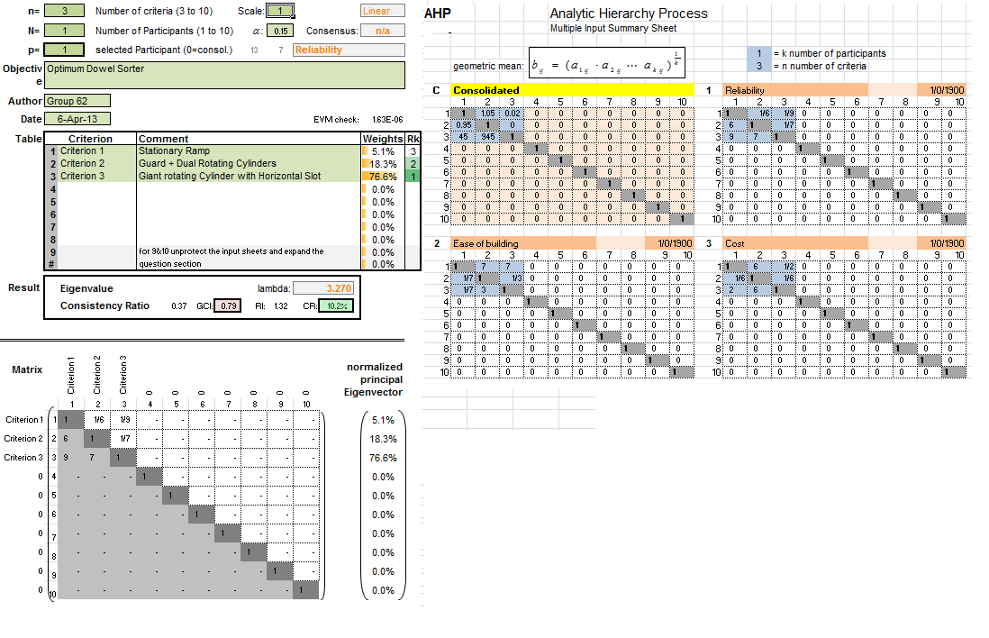

## 2.4 Budget

|  |  |  |  |  |  |
| --- | --- | --- | --- | --- | --- |
| **Machine Component** | **Item** | **Quantity** | **Cost per Item** | **Total Cost** | **Source** |
| **Mechanical** | 1X2 Plywood | 2 | 1.03 | 2.06 | Home depot |
|  | 1/8 Hardboard | 2 | 1.63 | 3.26 | Home depot |
|  | Aluminum Conveyor Frame | 1 | 12.58 | 12.58 | Metal Supermarkets |
|  | Screws | 16 | 0.36 | 5.76 | Home depot |
|  | Wood glue | 1 | 3.36 | 3.36 | Home depot |
|  | Epoxy | 1 | 8.79 | 8.79 | Home depot |
|  | Aluminum rod | 2 | 3.39 | 6.78 | Home depot |
|  | Wooden rod | 1 | 2.99 | 2.99 | Home Hardware |
|  | Nuts | 32 | 0.09 | 2.88 | Home depot |
|  | Nails | 17 | 0.01 | 0.17 | Home depot |
|  | Belt Fabric | 1 | 0.88 | 0.88 | Zellers |
|  | Plastic Cylinders | 2 | 1.5 | 3 | Dollarama |
|  | Gears | 6 | 0.5 | 3 | Active Surplus |
|  | Straight gear | 2 | 3 | 6 | Active Surplus |
|  | L-brackets | 8 | 0.25 | 2 | Home depot |
|  | Ductile Metal Chain | 1 | 7.5 | 7.5 | Home Hardware |
|  |  |  |  |  |  |
| **PIC controller board** | Devbugger | 1 | 50 | 50 | Prof. Emami |
|  | DS1307 Real-time chip | 1 | 6 | 6 | Design Store |
|  |  |  |  |  |  |
| **Sensors** | Sharp GP2Y0D805 Sensor | 1 | 3.84 | 3.84 | Digikey |
|  | Photoresistor | 2 | 0.1 | 0.2 | Digikey |
|  | LM358 Op-amp | 1 | 0.1 | 0.1 | Home Hardware |
|  |  |  |  |  |  |
| **Motor** | DC Motor | 5 | 5 | 25 | Design Store |
|  | Stepper Motor | 1 | 9 | 9 | Design Store |
|  |  |  |  |  |  |
| **Curcuit Board** | Soldered Protoboard (PCBDA-990000) | 4 | 1.89 | 7.56 | Creatron Inc. |
|  | Wires (per feet) | 19 feet | 0.1 | 1.9 | Home Hardware |
|  | TIP102 Transistors | 2 | 0.8 | 1.6 | Home Hardware |
|  | TIPL762A Transistors | 4 | 0.5 | 2 | Home Hardware |
|  | HC4050 Buffer | 1 | 3 | 3 | Design Store |
|  | SN754410 Transistor Array | 1 | 2 | 2 | Design Store |
|  | 0.1 mircroFarad capasitors | 7 | 0.1 | 0.7 | Design Store |
|  | Resistors (1\*4.7ohms, 3\*100ohms & 4\*10k ohms | 8 | 0.01 | 0.08 | Home Hardware |
|  | Switches | 2 | 1 | 2 | Design Store |
|  | 74HC14N logical NOT gate | 0.5 | 1 | 0.5 | Design Store |
|  | Potentiometer (Variable Resistor) | 4 | 0.2 | 0.8 | Home Hardware |
|  | IC sockets | 7 | 0.1 | 0.7 | Home Hardware |
|  | 5V Coil Relay | 1 | 3 | 3 | Design Store |
|  | Jumper wire Connectors | 8 | 0.2 | 1.6 | Home Hardware |
|  | 3W LED | 2 | 1.5 | 3 | Home Hardware |
|  | power supply | 1 | 15 | 15 | Design Store |
|  |  |  |  |  |  |
| **Total** |  |  |  | 210.59 |  |

# 3 Assessment of Problem (Perspective/Restrictions)

This section assesses the problem and solution through the perspective of restrictions imposed by the design and nature. Although there are machines that pack, they are quite bigger and much more complicated. Therefore the limitations placed on the project by the constraints [[3](#Gro13)] must be heavily considered:

1.    Be no larger than 75 cm x 75 cm x 75 cm

·         The design is required to be compact

2.    Weigh less than 6 kg

·         Light material must be used to build the machine

3.    Prototype costs should not exceed $230 CDN

·         Limited cap on price corresponds to a simple design

4.    Fully Autonomous

·         No interaction is allowed with external sources

·         2 minute time limit for production runs

In terms of the structure, electromechanically the machine should be compact and light allowing for easy transportation. The cap on price of the prototype and size restrictions cancel possibility of sophisticated designs such as autonomous arms used to pick up dowels as implemented in industry.

The motors suffer from a lack of torque at high speeds and therefore the speed cannot exceed a maximum limit depending on the motor. As a consequence, the design must also be efficient enough to complete the production run in under two minutes.

# 4 Subsystems

## 4.1 – Electromechanical System

### 4.1.1 Assessment of the Problem

The electromechanical member was required to make decisions on the materials and construction of the machine. The components of the machine were required to be durable and adhere to the constraints as set out in the proposal. In addition the machine needed to be portable due to the alternate work stations available for construction.

Primary construction materials were purchased from Home Depot, Metal Supermarkets, and taken from the AER201 shop’s scrap pile. To stay within the numerous constraints stated in section 3 adjustments and extra material decisions were made in terms of weight, strength, and cost.

The electromechanical design could be generalized into five major problems that significantly affected the design of the machine.

Problem 1: Sort at least 12 dowels at a time

Problem 2: Store at least 12 dowels into a compact reservoir.

Problem 3: Move boxes in order for dowels to be placed inside and lids closed.

Problem 4: Store at least 3 boxes in the limited space.

Problem 5: Mounting motors, sensors, PIC Microcontroller, and circuits.

Problem 6: Dowel Pusher functionality and implementations.

### 4.1.2 Solution

The design of this machine was implemented to be modular in which all the subsystems could be easily taken apart of restructure or adjustment. The modularity of the subsystems made integration easier as the entire machine was not needed when integrating certain features.

The total weight of the machine was 6 kg and its total dimensions are 65 cm in height, 60 cm length and 45 cm width.

#### 4.1.2.1 Sorter

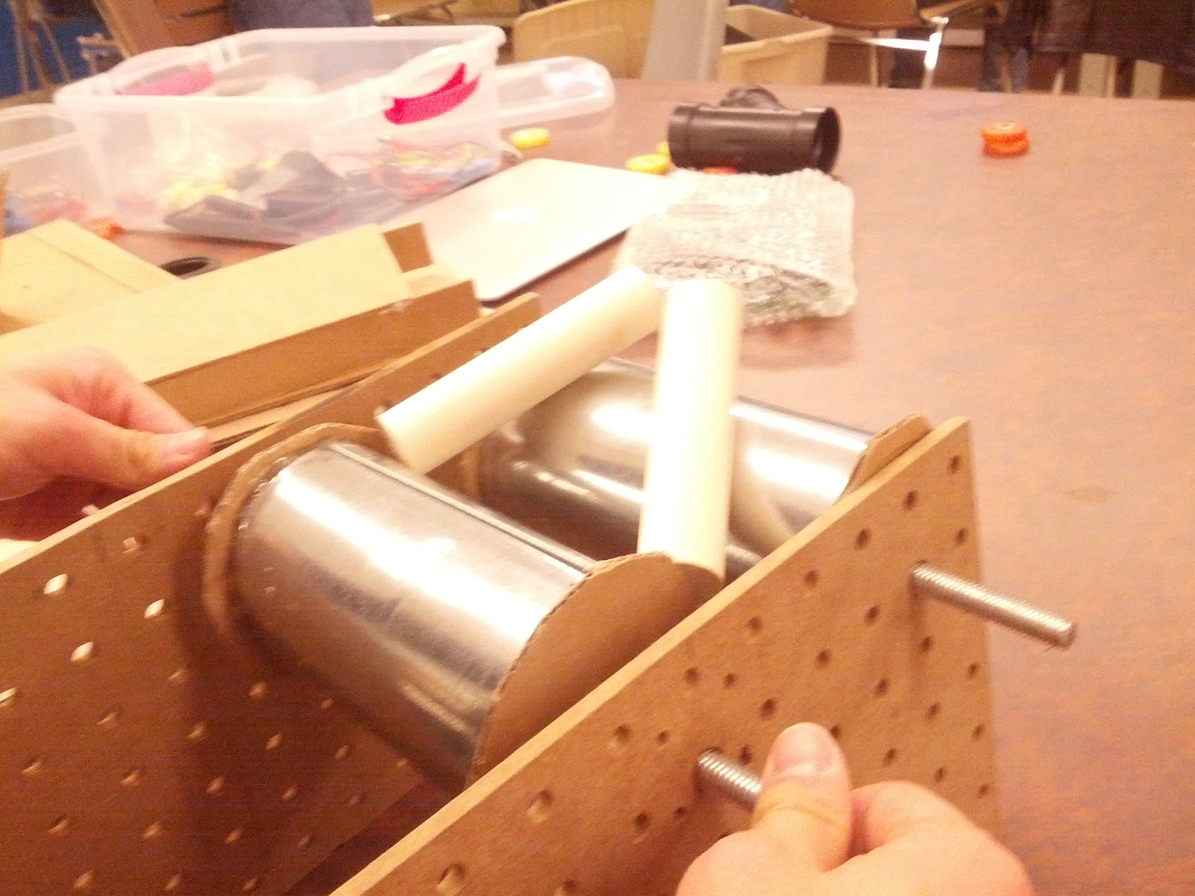  
Figure 4.1.2.1: Initial Dowel Sorter Prototype

The dowel sorter was the most complicated part of the machine due to size constraints and lack of practical reference design. In industry cylindrical objects are mostly either selected by robotic arms or shaken on a moving belt. Both of these designs were deemed impractical due to the expense and vast proportion of space required.

Originally the design from the proposal was implemented (figure 4.1.2.1). This involved two cylindrical rollers that would orient the dowels horizontally on the x axis in order to fall into the reservoir. This design worked approximately 25% of the time. Multiple dowels would overload the sorter and cause it to not function properly. If a dowel’s orientation was to line up with the z axis it would jam by locking in between the reservoir and the sorters often causing a total breakdown of the subsystem.

Figure 4.1.2.2: Dowel Sorter and reservoir combination before design change

Adjustments were made to the original design by adding different variations of teeth to the cylindrical rollers (figure 4.1.2.2). Initially aluminum cups were attempted to grab dowels, but they did not orient the dowels. The cups were then cut into teeth to help change the orientation of dowels, but this resulted in a 40% decrease in the ability to lift dowels. In order to combat this massive decrease in functionality rubber cups were made out of an air tube. This worked significantly better, but as with the original design, could not account for multiple dowels, specifically more than 5.

It became apparent that this design was not particularly capable of sorting many dowels so a design change decision had to be made. After consulting with other groups and considering the time available to build something from scratch, a new design was drafted as a giant cylindrical tub. This tub would be large enough to house 12 dowels and contain a slit that when rotated would allow for only one dowel to fall out at a time. In addition the centrifugal force would ensure that the dowels would be orientated along the x axis. This design worked 90% of time and was considered successful as long as the motor was strong enough to move it at a constant high speed.

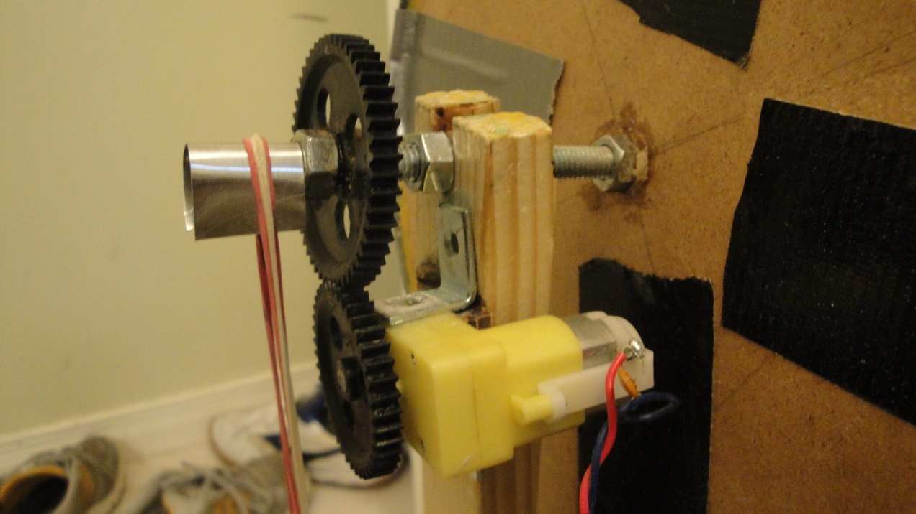  
Figure 4.1.2.3: Gears for new Dowel Sorter

The Dowel sorter used a gear ratio 3:2 to control the speed of the sorter (figure 4.1.2.3). Unlike the old design, the new design works for dowels in any orientation and can easily sort up to 7 dowels.

Gear Ratio Formula and Calculations:

$$ɳ= \frac{ω_{m}}{ω_{l}}$$

Gear 1 angular frequency = 2 $π$/ T = 12.56 rad/s

Gear 2 angular frequency = 2 $π$/ T = 8.38 rad/s

$ɳ= \frac{12.56}{8.38}=\frac{3}{2}$

#### 4.1.2.2 Reservoir

The dowel reservoir is required to house 12 dowels, be able to hold a sensor that counted the amount of dowels in it and fit within the size constraints. If the reservoir was mounted vertically it would take approximately 35 cm due to the diameter of each dowel being 2.5 cm. This is nearly half of the size restriction and with respect to the sorter and conveyor was impractical. Also if the reservoirs were to be placed horizontally, the dowels would need to be pushed to the exit end in order to package the dowels properly. That would require an additional motor and sensor pair to ensure proper function.

Hence a diagonal reservoir that rested 45 degrees above the horizontal proved as the optimum solution. The new height and weight of the reservoir is 35 cm / $\sqrt{2}$ = 25 cm in accordance to Pythagoras’ theorem (figure 4.1.2.2). The new orientation allows for space both below and above the reservoir to place extra features like sensors, motors, and the dowel aligner.

#### 4.1.2.3 Conveyor System

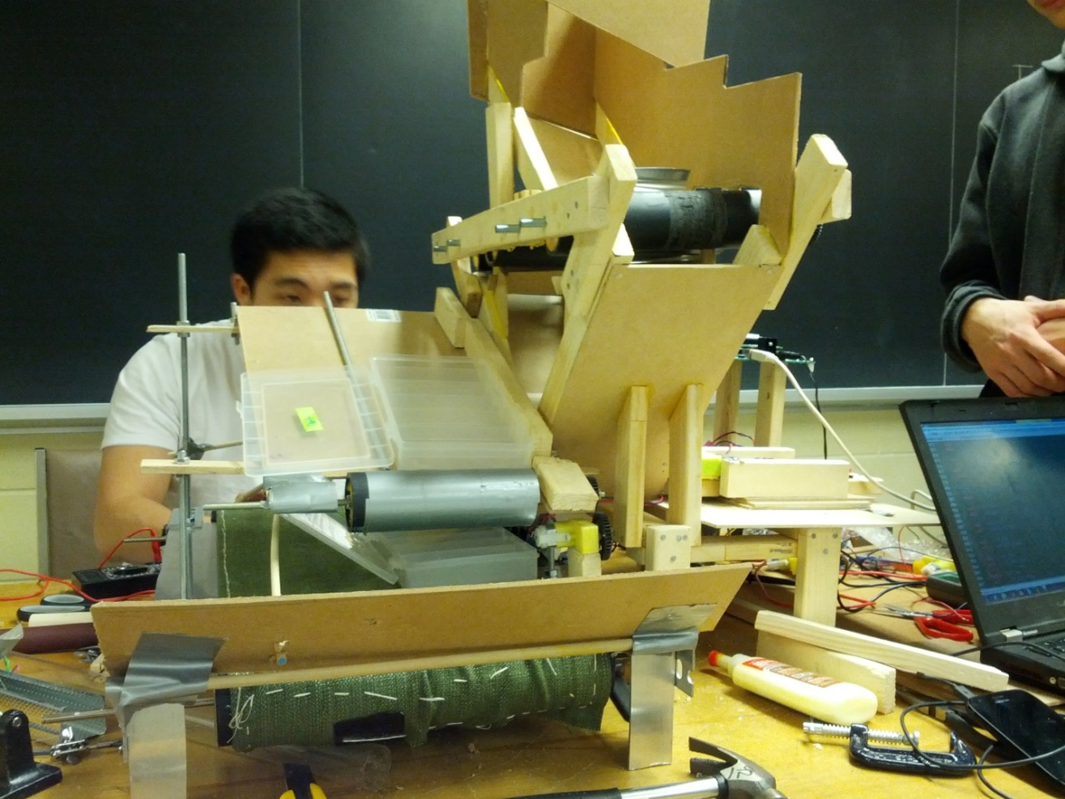  
Figure 4.1.2.4: Conveyor system and Box loader

The conveyor system (figure 4.1.2.4) was considered to be the main frame subsystem of the machine. It has direct contact with the reservoirs, box loader, dowel pushers, and the pickup area. Therefore this system was required to be completed first to allow for early testing and debugging.

The frame of the conveyor belt was created out of aluminum purchased from Metal Supermarkets. Aluminum was selected over wood due to its ability to be much more frictionless. It came with a higher price and weight. In order to reduce the weight, the legs and side of the conveyor were cut off.

The rollers of the conveyor belt were made out of 1 ½’ PVC pipe with wooden caps on both ends. The axels were secured with nuts and epoxy. Due to the fact that there was a chance for shear, the belt material was required to not cause too much of a strain on the rollers.

The original material was three rubber mats duct taped together. The rubber mats had a bent which caused a big disturbance to the rollers. Rubber conveyor belt material was purchased to provide better traction. This material was significantly more expensive at $5 per foot and had other disadvantages in terms of inability to attach both ends and massive force applied upon the rollers.

Cloth was chosen as a better alternative to address the three problems of the conveyor belt material by being much cheaper, able to be stitched together, and not strain the rollers. The cloth was strong enough to move a box loaded with 6 dowels without any lag. The conveyor subsystem worked 100% of the time during tests and demo.

The conveyor belt stretched 120cm x 25 cm around rollers with 8 cm diameters. The aluminum frame dimensions are 60 cm x 35 cm x 0.3 cm. The legs of the frame are 4 cm x 2 cm x 4 cm. The height of the legs was cut from 10 cm to 4 cm to provide more height for the rest of the machine.

The closing mechanism was built out of three wooden sticks positioned in a triangle formation that was lifted slightly higher at one end than the other to guide the lid up. This height was adjustable due to the build with elastic bands.

#### 4.1.2.4 Box Loader

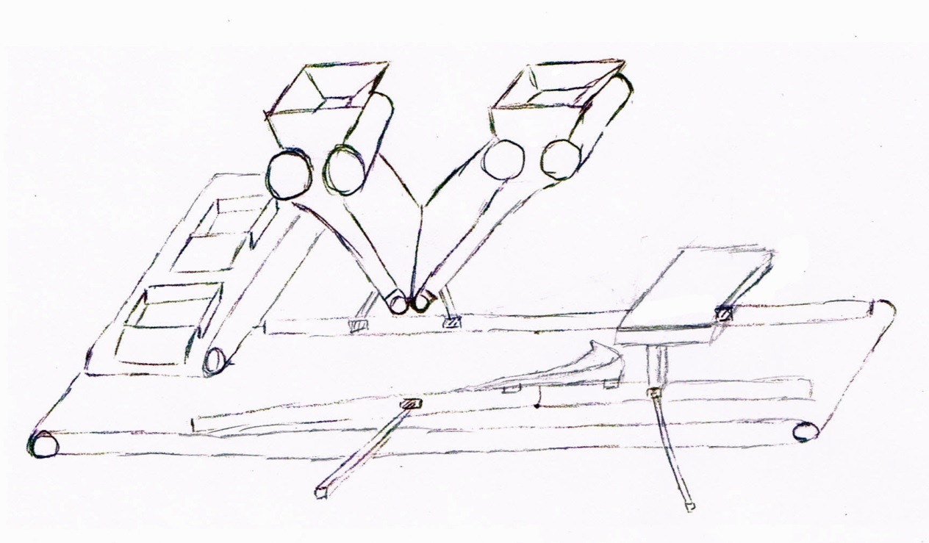  
Figure 4.1.2.5: Initial Box loader design from proposal

The original design of the box loader as requested in the project proposal was an adjacent conveyor belt (figure 4.1.2.5). Building this grew difficult after creating the first conveyor belt due to the difficulty to build a reliable conveyor and the size constraints. Boxes could not be stacked upon each other due to the pieces in the bottom of one box that would get stuck to the top of the box below it.

An alternative solution was needed in order to incorporate the space and simplicity requirements. Therefore the box loader subsystem was designed to be placed upon the conveyor subsystem and use the force of gravity with a small push of a dc motor to function (figure 4.1.2.4).

This design was simple, but required a fair bit of debugging to provide the best possible output. The wooden supports were not strong enough to be launch onto the aluminum frame of the conveyor and would often become detached. To fix this problem metal spiral supports were introduced that could be adjusted with the nuts used to hold the bow loader in place. The roller attached to a dc motor was created with PVC piping that did not have much friction. Extended rubber bands were added to the roller to help “pull” the box down to the packing conveyor belt.

#### 4.1.2.5 Dowel Pusher

Once in the reservoir, the dowels were required to be pushed into the box. A significant amount of force was necessary due to the added weight of the dowels on top of it. Thus a motor driven linear actuator was implemented to push the dowels. In addition, the linear actuator needed to return to the same position it started from or eventually it would get dislodged from the motor.

From this arose two problems. The first being that the motors needed to be mounted firmly and the second being that the dowels needed to be in the same position each time.

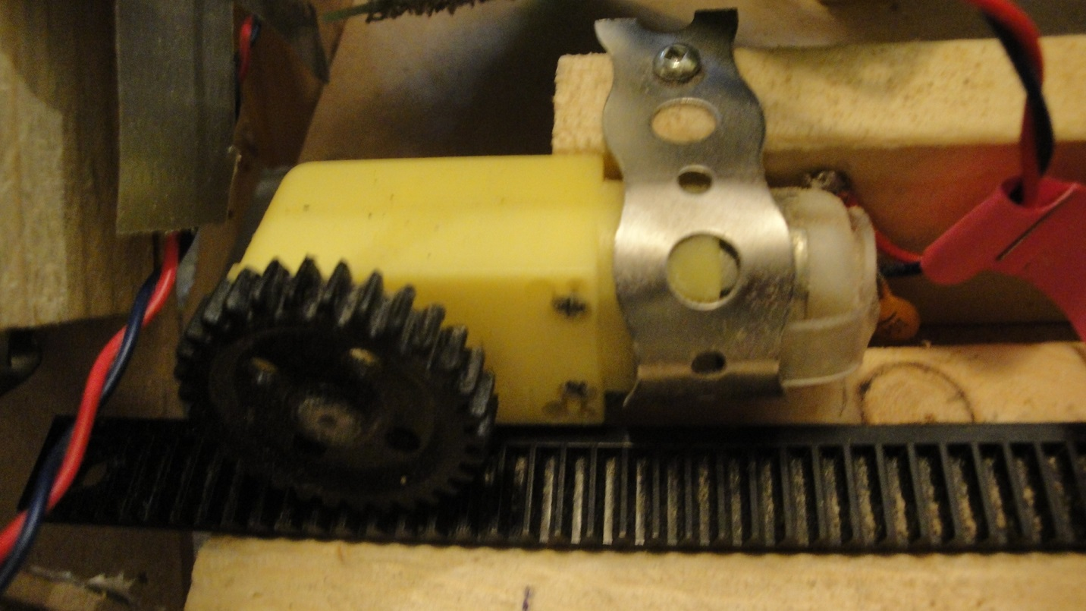Figure 4.1.2.6: DC operated linear actuator

Mounting the motors with glue or epoxy was not strong enough and so a ductile metal chain was enclosed around the motors to provide extra support (figure 4.1.2.6). The chain was screwed into a wooden block.

After the pusher had exited one of the dowels the other dowels would often become stuck in a position that the actuator could not reach. To fix this problem, the inside edges of the reservoir were sanded down to reduce the friction and allowing the dowels to slip into position. Also a guard was placed on top of the dowels in the reservoirs to slightly push the dowels downwards.

## 4.1.3 Suggestions for Improvement of the Subsystem

There are still areas that could be improved in the current model of the machine. The issues that could be resolved would aid in the functionality and durability of the machine.

A few problems that have been pin pointed are:

1. **The dowel sorting mechanism cannot sort more than 7 dowels at a time.** An improvement to this design would be to increase the size of the container allowing for a bigger volume for dowels to become aligned.
2. **The closing mechanism did not shut the lid completely.** Attempts to find the perfect height to close the box shuts were tried, but not found do to variation of box location. To improve this design, a more precise box position should be implemented so the box will follow the same exact path each time.
3. **The box loader was not precise.** The box loader served its purpose to hold and release the boxes in a routine manner. Unfortunately due to the height between the loader and the conveyor belt, sometimes the box would not land exactly in the right position causing the dowels to not be packaged properly and the lid to not snap shut. Although the “jiggling” feature of the conveyor belt corrected misaligned dowels, the inaccuracy of box position on the conveyor belt is still an issue that needs to be resolved. An improvement to this problem would be like the suggestion for the previous problem, a precise box position with possible guide rails.

|  |  |  |  |  |
| --- | --- | --- | --- | --- |
| Subsystem | Height (cm) | Length (cm) | Width (cm) | Weight (kg) |
| Sorter 1 | 21 | 21 | 21 | 0.3 |
| Sorter 2 | 21 | 21 | 21 | 0.3 |
| Reservoir 1 | 25 | 25 | 14 | 0.25 |
| Reservoir 2 | 25 | 25 | 14 | 0.25 |
| Conveyor | 6 | 65 | 25 | 2.25 |
| Box Loader | 8 | 60 | 23 | 0.25 |
| Dowel Pusher 1 | 1.3 | 16 | 1 | 0.95 |
| Dowel Pusher 2 | 1.3 | 16 | 1 | 0.95 |
|  |  |  |  |  |
| Machine | 60 | 70 | 45 | 5.9 |

Table 4.1.3.1: Dimensions and weight of machine

1. **The weight was close to maximum.** By measuring each subsystem with their respective sensors and motors and power supply, the weight of the machine came to 5.9 kg which is dangerously close to the maximum limit of 6 kg [[3](#Gro13)] (table 4.1.3.1). To improve the system, light material should be used such as wood instead of rigid aluminum and excess space should be cut.

## 4.2 Circuits

### 4.2.1 Assessment of the Problem

The circuit subsystem acts as a bridge to enable the communication between the PIC controller and the mechanical components. In particular, it must provide the following functionalities:

1. Power supply

A 12V DC power supply is required for both the PIC controller and the stepper motor whereas a 5V DC power supply is required for all other electrical components including the relay, DC motors, proximity sensors (including the 8-to-3 encoding PCB), LEDs, light sensors and emergency stop.

1. PIC controller interface

A 40-pin IC socket onto one of the PCBs is required to allow communication between the PIC controller and other electrical boards.

1. Relay

A relay is required as an external switch to control PIC Port B being the input or output.

1. Unidirectional DC motor

Three unidirectional DC motors are required for the rotating cylinder as well as the box loader.

1. Bidirectional DC motor

Two bidirectional DC motors whose ON/OFF and direction controlled by the PIC are required for the dowel pusher.

1. Stepper motor

One stepper motor is required to power the conveyor belt with a minimum power of 1.23W.

1. Proximity sensor (and the 8-to-3 encoding board)

One sharp GP2Y0D805 sensor was purchased to detect the exact position of the box. However, a carrier circuit is required to be soldered manually in order to make use of it according to its datasheet.

1. Light sensor

Two light sensors composed of CdS photo-resistors and a LM358 Op-amp are required at the outlet of each reservoir to detect if a sorted dowel has dropped from the rotating cylinder.

1. LED circuit

Two 3W LEDs are required across the dowel reservoir opposing the light photo-resistors in order to enable the photo-resisters as well as to minimize environmental lighting effects.

1. Emergency stop

A physical switch is required directly connected in serial to the power supply as a simple mechanism to stop all electrical and mechanical components of the machine.

1. Connection between PCBs

All PCBs in the system are required to connect to each other using jumper wires.

### 4.2.2 Solution

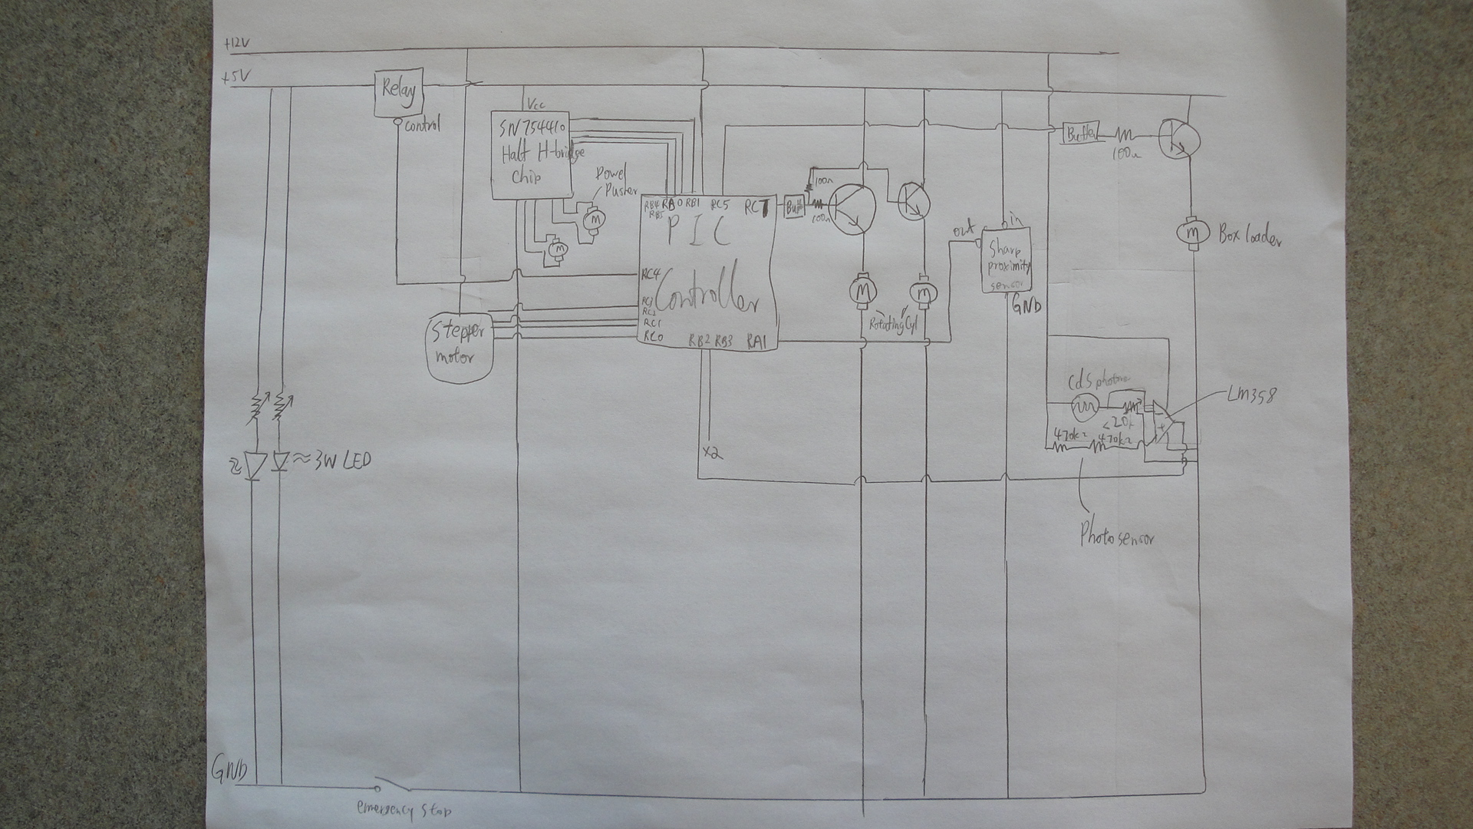

Figure 4.2.2.1: Overall Circuit

#### 4.2.2.1 Power Supply

#### powerSupply.jpg Figure 4.2.2.2: Power supply

This machine is powered by the power supply provided in the AER201 design kit as shown in Fig. 4.2.2.2. The particular power adaptor converts 120V AC into 5V DC with a max current of 3A and 12V DC with a max current of 2A. It should be noted that the wire color coding for all power supply jumper wires throughout this project goes as following:

Ground: Black wire

+5V: Red wire

+12V: Yellow wire

The choice of an AC adaptor over 8 AA batteries connected in serial is made for a number of reasons. First of all, the AC adaptor can provide a consistent voltage supply at all times whereas the voltage supplied by the batteries changes as it is used. In fact, it was observed that the DC motors run at significantly different speed as batteries die out, and the consistency of reusability of the AC adaptor will definitely simplify the system debugging process. Furthermore, the usage of AC adaptor prevents the disposal of batteries which contain detrimental materials like mercury and lead and environmental friendly improves the sustainability design aspect of this machine. Finally and most importantly, the choice of AC adaptor is applicable as the machine is designed to be immobile.

The output of the three wires of the AC adaptor goes into the power hub PCB as shown in Fig.4.2.2.3. The power hub PCB then provides 12V DC to the PIC controller and the stepper motor with 5V DC to other electrical components including the relay, DC motors, proximity sensors (including the 8-to-3 encoding PCB), LEDs, light sensors and emergency stop.

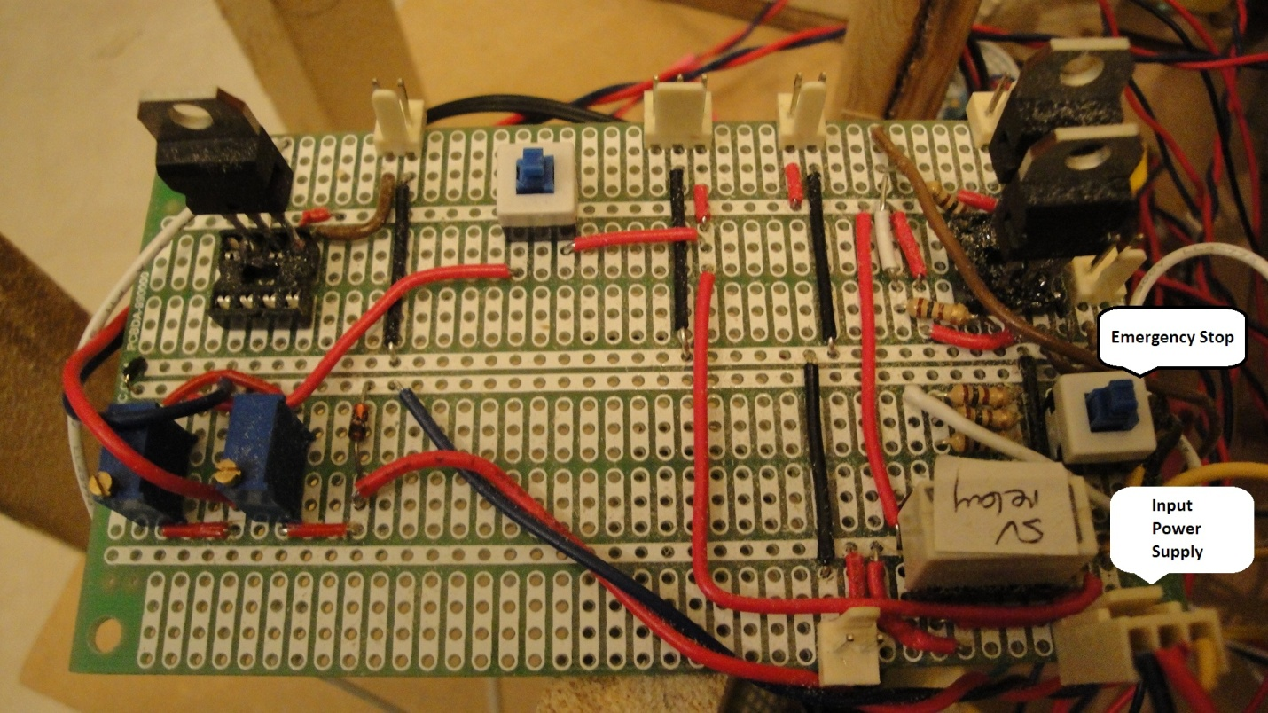

Fig.4.2.2.3: The soldered power hub PCB

#### 4.2.2.2 PIC Controller Interface

A 40-pin (20\*2) male socket is purchased from Home Hardware and soldered directly onto the signal hub PCB as shown in Fig. 4.2.2.4. Each pin is then connected to the proper transducers/drivers via jumper wires and connectors between PCBs according to the pin assignment shown in Appendix N. The color coding for this particular PIC interface goes as followings:

Signal from sensors: Green wire

Signal to motors: Brown wire

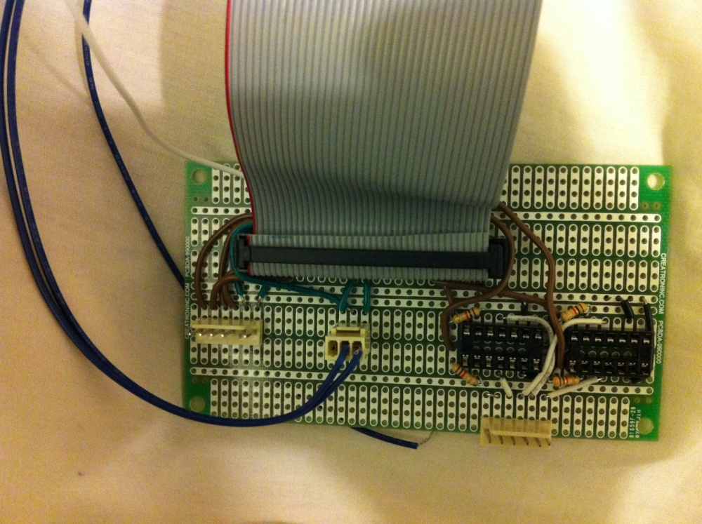

Fig.4.2.2.4: PIC control interface / signal hub

#### 4.2.2.3 Relay

Since PORTB is used both as an input port (KEYPAD) and an output port (DC motor control) it is crucial to control the connections between PORTB, KEYPAD and DC motor to yield desired results. The first step we took to achieve this goal is to use the KPD pin on the Devbugger, however it failed to work when it was correctly configured (both in software and in hardware, i.e jumper connection), motors responded to keypad presses even when KPD bit is set to enable KEYPAD. We have consulted Professor Emami for possible reasons and it might have to do with malfunctioning internal buffer. The two most feasible alternative solutions are listed below:

1. Use a relay / transistor as a master power switch for DC motors (FIG 4.2.2.5)
2. Use MUXs and pull-down resistors to prevent DC motors from responding to KEYPAD (FIG 4.2.2.5)



Fig. 4.2.2.5: Two different approaches to solve the PORT B being input and output issue (MUX approach on the left and relay approach on the right)

We decided to use a mechanical relay as a master power switch for 5V source, see FIG.4.2.2.1 for circuit diagram.

The relay is open before operation starts, thus effectively disabling all DC motors that are connected to the 5V source. This includes dowel sorters, box loader, and dowel pusher. Relay is closed when operation starts, at which point KEYPAD will no longer be used until termination sequence is evoked, where relay is opened again to prevent DC motors from responding to KEYPAD presses.

#### 4.2.2.4 Unidirectional DC Motor

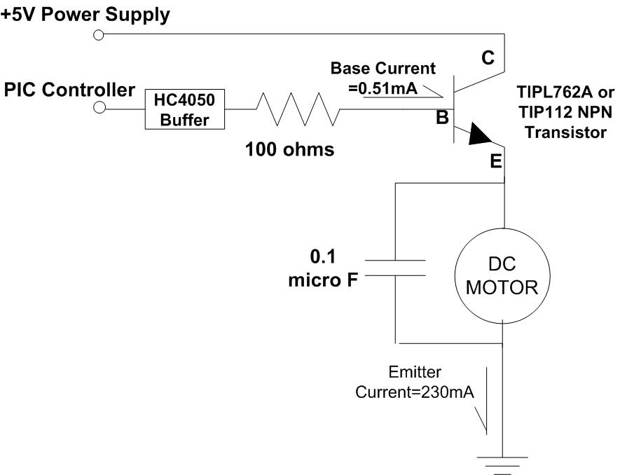  
Figure 4.2.2.6: PIC controller and circuit diagram

Three unidirectional DC motors are installed for the two rotating cylinders as well as the box loader. Each unidirectional DC motor is controlled by a single TIP112 NPN power transistor whose base is in turn controlled by a pin on the PIC controller, and the circuit diagram is shown in Fig. 4.2.2.6. The collector (C) of the NPN transistor is directly connected to +5V power supply whereas the base is connected to a 10 ohms resistor and HC4050 buffer in serial to limit voltage across the DC motor as well as to minimize current drawn from the PIC controller. Using the circuit shown above, it is measured experimentally that base current into the TIP112 NPN transistor is 0.51mA when the motor rotates freely. This current is way less than the output limitation of the PIC controller (25mA), indicating a safe circuit to be powered by the PIC controller. A fully labelled soldered circuit on PCB identical to the one above is presented in Fig. 4.2.2.7.

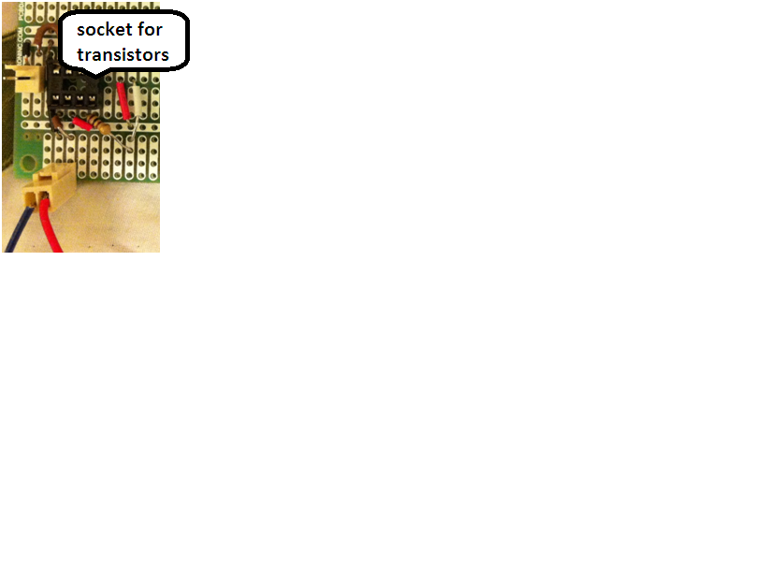

Fig. 4.2.2.7: Soldered PCB for unidirectional motor

All three unidirectional DC motors used are the plastic Shenzhen TGP02S-A130 gear motor (datasheet see Appendix P) as shown in Fig.4.2.2.8. This particular gear motor can operate in a voltage range from 3V to 12V and by utilizing the circuit above, it can operate at a safe voltage of 3V. Although it draws a current of 230mA at low load, its current can rise up to 0.9A when greater torque is required. Therefore, care must be taken when choosing the power supply to ensure that it can provide enough current for it. Furthermore, the wires connected to the motor are twisted to minimize the back magnetic flux produced by the motor and a 0.1µF capacitor is connected in parallel with the motor to minimize the effect of the magnetic flux produced at the moment when the motor is turned on or off.

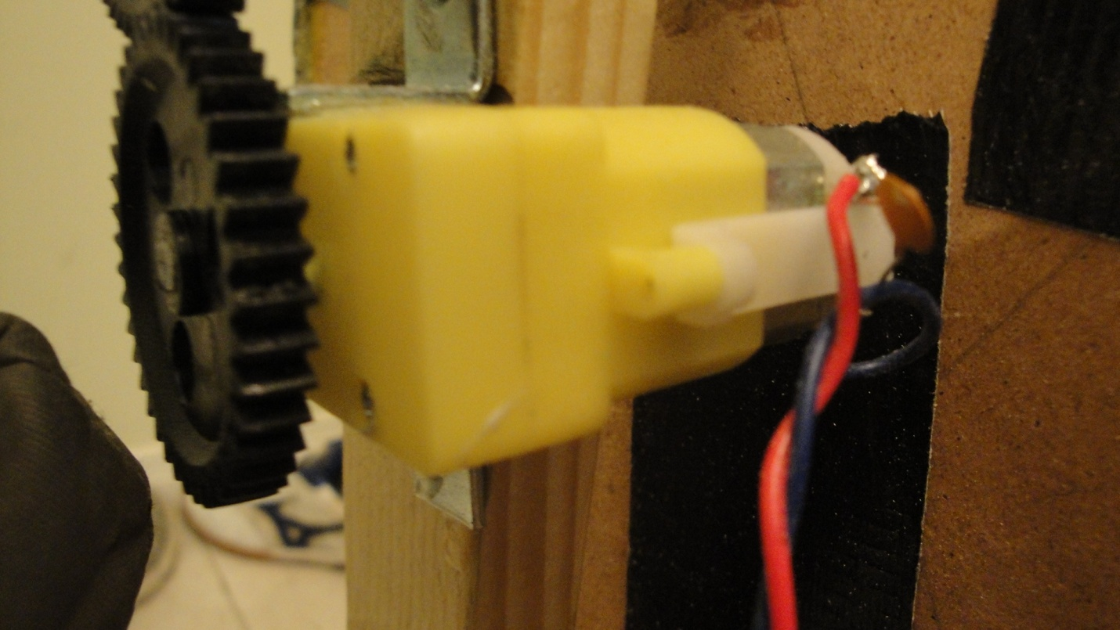

Fig.4.2.2.8: Motor with capacitor and twisted wires for noise filtration

#### 4.2.2.5 Bidirectional DC Motor (SIMULATION VIDEO ON YOUTUBE!!!)

Two bidirectional DC motors drivers are built using the SN754410 half-bridge IC (datasheet see Appendix G) to drive the two bidirectional motors for the dowel pushers. The circuit diagram and the corresponding soldered PCBs are shown in Fig. 4.2.2.9. Both Vcc1 and Vcc2 are connected to +5V to supply power to the IC, and all four heat sinks (middle pins) are connected directly to ground to take away additional heat produced by the transistor array inside the chip. The enable pin is connected to a 10kΩ resistor and then connected to the ON/OFF control pin on the PIC controller to minimize current drain. The two inputs pin (1A and 2A) are connected to two 10kΩ resistor and joined together to the PIC controller via one Schmitt inverter. In this way, the Schmitt inverter guarantees that the logical value of the two inputs to the IC will always opposes each other. For instance, when the directional control is given logical “1” (i.e +5V), transistor 1A will be given +5V and transistor 2A will be given 0V in which case the motor will rotate in one direction and when the directional control pin is given a logical “0”, transistor 1A will be given 0V and transistor 2A will be given +5V making the motor to rotate in the other direction. The motors used are identical to the unidirectional ones except for the fact that they have straight heads, and as a consequence, they are protected from the back magnetic flux using similar methods by twisting the connecting wires as well as a parallel 0.1µF capacitor. The color coding for the particular PCB soldered goes as followings:

Heat sink/GND: Black wire

Connection to the DC motor: White wire

Logical circuit for the NOT gate: Orange wire

Signal input from PIC controller: Brown wire

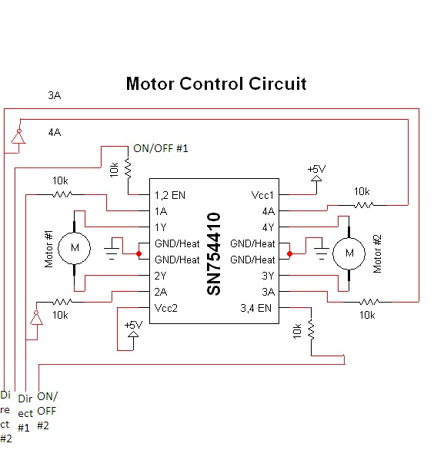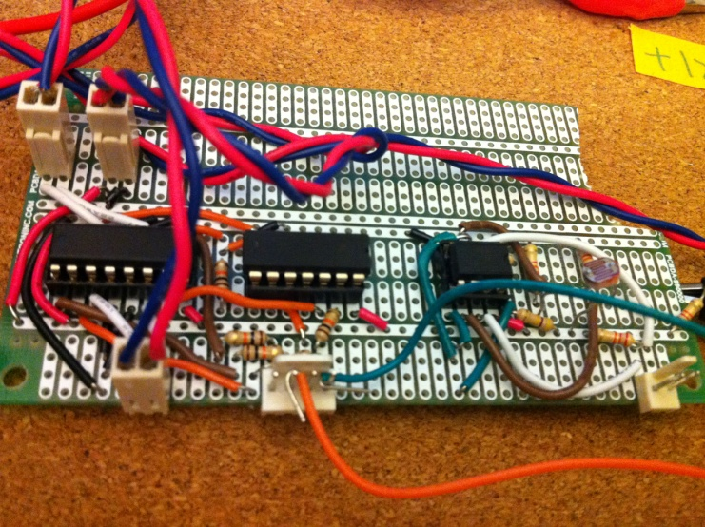

Fig.4.2.2.9: Bidirectional motor control using a SN754410 half H-bridge IC and its corresponding soldered PCB [[4](#Pyr13)].

#### 4.2.2.6 Stepper motor

The KP48FP8G-504 stepper motor provided in the design store is used to power the convey belt. The driving circuit for the stepper motor is shown in Fig. 4.2.2.10 where 12V power supply is directly connected to the centroids of both coils, and the other four ends are connected to the collector (C) of four NPN bipolar transistors whose bases are connected by the PIC controller. By giving a particular logical sequence to the bases of the four transistors (see Fig.4.2.2.11), the stepper motor can be activated to operate in both directions. An alternate approach to this problem is to utilize the 74LS194 shift register and the 555 timer so that the stepper motor can be controlled by only two pins from the PIC controller as it is shown in Fig. 4.2.2.11. The benefit of this alternative approach is: 1) Save two pins from the PIC controller interface; 2) Stepper motor can be activated by simply setting S0 to logical “1” and S1 to logical “0” so that the software is free to do other independent jobs. However, the first approach (i.e without sift register and timer) is taken as there is no other concurrent events happening in the machine when the stepper motor is running, and the first approach can be easily achieved by pulling I/O on each of the four transistor bases via software implementation. Another advantage of the first approach is that the speed of the stepper motor can be controlled by simply changing the delay function between each pulling command in the software. The color coding of the stepper motor can be determined by measuring the internal resistance between all six wires in order to determine which three belong to the same coil and the result turns out to be as followings:

Green wire (\*2): centroids of two coils, apply 12V DC to them

Yellow wire: 1b

Red wire: 2a

Blue wire: 2b

White wire: 1a

As it was noted earlier, the conveyor belt requires a certain torque to be powered and since

$$Power=Torque*Speed$$

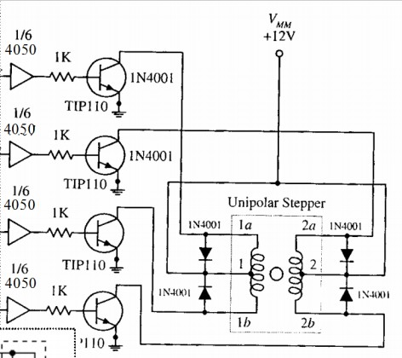  
Figure 4.2.2.10: Stepper motor driver circuit

And giving that the power output from the stepper motor is relatively constant, a greater torque required indicates a lower operating speed, which is not desired giving the constraint operation time being limited to 2 minutes. As a consequence, the powering mode sequence (see Table 4.2.2.1) is actually implemented onto the machine which always activates two electromagnets instead of one. Under this mode, the stepper motor consumes twice as much as power and outputs a power 1.4 times higher than the normal mode. The increase in its output power enables the conveyor belt to move at a faster speed.

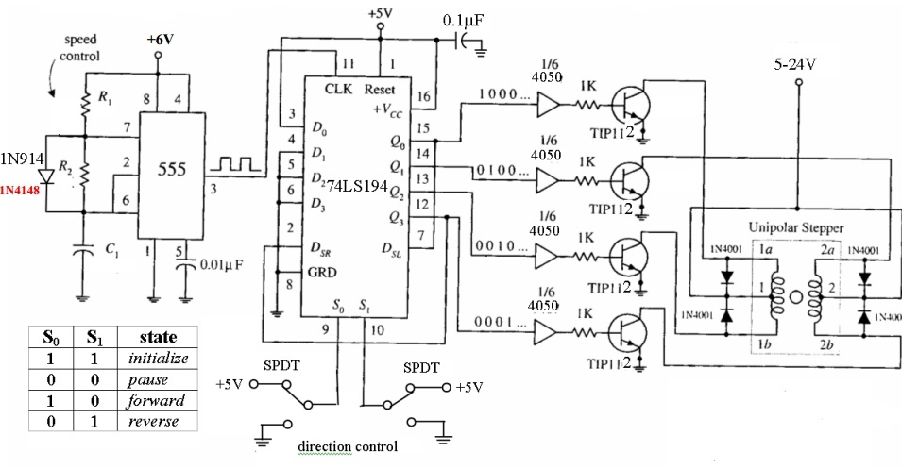  
Figure 4.2.2.11: Alternative stepper motor driver circuit

|  |  |  |  |  |  |  |  |  |
| --- | --- | --- | --- | --- | --- | --- | --- | --- |
| Time | Normal Mode | | | | Power Mode | | | |
| Top-down: forward direction  Down-top: reverse direction | 1a | 1b | 2a | 2b | 1a | 1b | 2a | 2b |
| 1 | 0 | 0 | 0 | 1 | 0 | 0 | 1 |
| 0 | 0 | 1 | 0 | 1 | 0 | 1 | 0 |
| 0 | 1 | 0 | 0 | 0 | 1 | 1 | 0 |
| 0 | 0 | 0 | 1 | 0 | 1 | 0 | 1 |

Table 4.2.2.12: Stepper motor normal mode and power mode sequence

#### 4.2.2.7 Proximity Sensor (and the 8-to-3-encoding PCB)

Sharp GP2Y0D805 proximity sensors (see Fig. 4.2.2.12 whose datasheet is given in appendix D) were purchased and installed along the conveyor belt in order to detect the exact position of the box waiting to be packed. However, the Sharp GP2Y0D805 proximity sensor purchased from Digikey does not come with the carrier PCB, and as a consequence, 8 carrier circuits are soldered manually for those sensors according to its Pololu carrier shown in Fig.4.2.2.13 and the eight carriers soldered onto PCBs are shown in Fig. 4.2.2.14. [[5](#Pol13)]

Once the carrier is soldered, each proximity sensor can be installed into place by connecting the Vcc to +5V and ground to the common ground, the data output can be read directly from pin 13. For the GP2Y0D805 in particular, it will give a logical “1” when there are no objects and a logical “0” when there is one. This particular sensor is chosen to sense the box as it relies on IR reflection, which is suitable for the transparent box in this case.

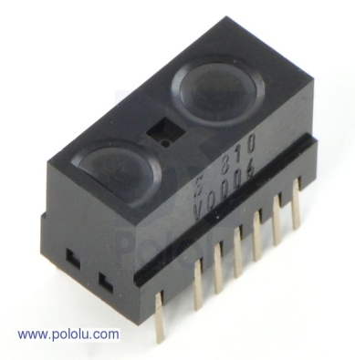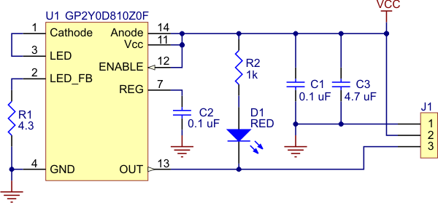

Fig.4.2.2.13: GP2Y0D805 IR proximity sensor and its carrier circuit

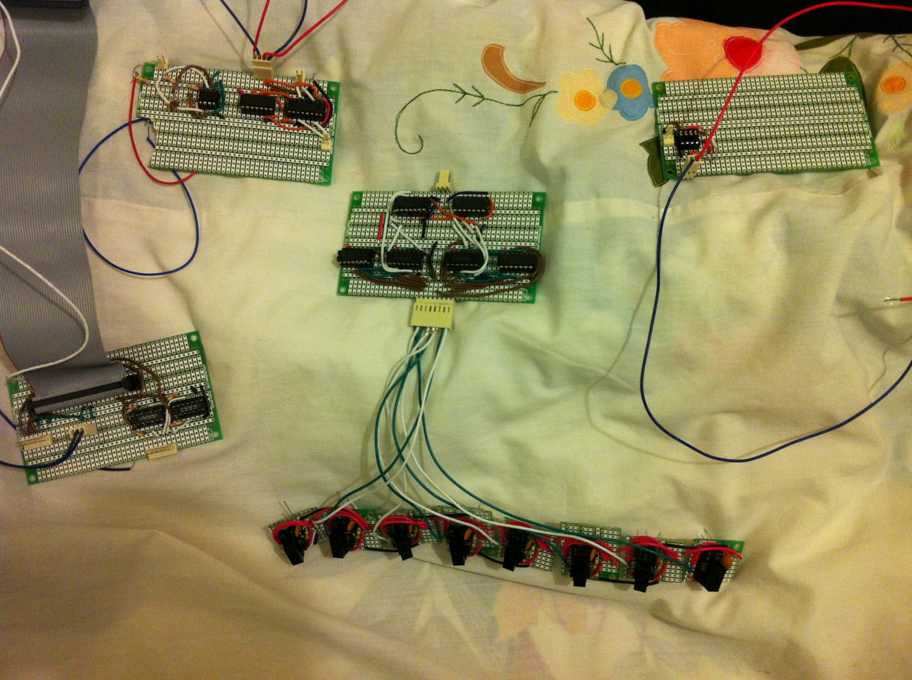

Fig.4.2.2.14: 8 soldered carrier circuits and the 8-to-3 binary encoder PCB

As an initial attempt to detect the box position, 8 proximity sensors were soldered side-by-side with an adjacent distance of 3.3cm (Fig. 4.2.2.14), which equals to the adjacent distance between two slits in the box. In order to save pins from the PIC controller interface, an 8-to-3 binary encoder is also attached in between to convert the 8 digital signals into 3 encoded binary signals that are transported directly into Port A0, A1 and A2 on the PIC, and the encoding truth table is given in Table 4.2.2.2.

|  |  |  |  |  |  |  |  |  |  |  |  |
| --- | --- | --- | --- | --- | --- | --- | --- | --- | --- | --- | --- |
| Stage | Sensor #1 | Sensor #2 | Sensor #3 | Sensor #4 | Sensor #5 | Sensor #6 | Sensor #7 | Sensor #8 | Corresponding encoded value | | |
| RA2 | RA1 | RA0 |
| 1 | 0 | 0 | 0 | 0 | 0 | 0 | 0 | 0 | 0 | 0 | 0 |
| 2 | 1 | 0 | 0 | 0 | 0 | 0 | 0 | 0 | 0 | 0 | 1 |
| 3 | 0 | 1 | 0 | 0 | 0 | 0 | 0 | 0 | 0 | 1 | 0 |
| 4 | 0 | 0 | 1 | 0 | 0 | 0 | 0 | 0 | 0 | 1 | 1 |
| 5 | 0 | 0 | 0 | 1 | 0 | 0 | 0 | 0 | 1 | 0 | 0 |
| 6 | 0 | 0 | 0 | 0 | 1 | 0 | 0 | 0 | 1 | 0 | 1 |
| 7 | 0 | 0 | 0 | 0 | 0 | 1 | 0 | 0 | 1 | 1 | 0 |
| 8 | 0 | 0 | 0 | 0 | 0 | 0 | 1 | 0 | 1 | 1 | 1 |

Table 4.2.2.2: Truth table required to binary-encode the sensor data in order to know its position

As it is demonstrated in the truth table, the final logical expression for RA0, RA1 and RA2 goes as followings:

RA2=S4 OR S5 OR S6 OR S7 OR S8

RA1= S3 OR S4 OR S7 OR S8

RA0= S2 OR S4 OR S6 OR S8

And the soldered 8-to-3 binary encoding PCB is shown in 4.2.2.14. However, a major problem with this approach is the misalignment of the sensors. As it is indicated in the datasheet, the particular GP2Y0D805 proximity sensor used can only “observe” objects in the 3cm to 5cm range. And in the cases where the sensors are not perfectly parallel to the box, one misaligned sensor may lead to wrong judgement of box position. Although a number of efforts have been attempted to stabilize the sensors on a wooden piece/aluminum frame, mis-judgement of the box position is still a problem when pushing the dowels as the box position differs slightly every time due to subtle motion of the conveyor belt. As an improved and current design, only one sensor is used to detect the initial position of the box, and once the box is detected, certain delay function is given to the stepper motor to ensure that the dowel pusher now aligns with the position of next slit of the box. In this way, as long as the first sensor senses the head of the box, all subsequent dowels will be pushed into the correct spot with a successful rate of more than 95%.

4.2.2.8 Light sensor

Two light sensors composed of CdS photo-resistors and a LM358 Op-amp are required at the outlet of each reservoir to detect if a sorted dowel has dropped from the rotating cylinder. Trimmer resistors are used to compensate for ambient light condition differences. Under normal light condition (regular lecture room) the resistance value of LDR ranges from ~10 Ω (next to the 3W LED) to 3.5kΩ (completely covered). And through empirical testing, it is determined that the resistance values of LDR with a single 3W LED shining one dowel length away is 1.4kΩ and 2.5kΩ when a dowel blocks it. Therefore the trimmer resistor value is selected at 20kΩ, adjustable from 1Ω to maximum of 20kΩ. See FIG 4.2.2.1 for circuit diagram. When there’s no dowel blocking the LDR, OP-AMP will be saturated to +Vcc (5v) due to the large positive gain of OP-AMP, and when a dowel blocks the LDR, OP-AMP output will saturate to –Vcc (0v) due to the large negative gain, thus enabling dowel detection

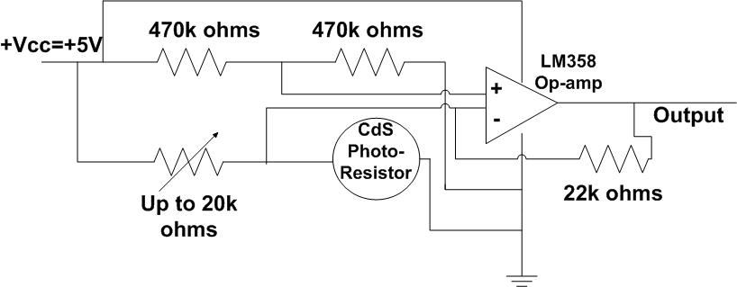

Fig.4.2.2.14: Photoresistor circuit diagram with a LM358 comparator to converts the analog voltage signal to digital

When a dowel falls and blocks the LDR, a positive edge (change from 0v to 5v) will be generated at the OP-AMP output where it is connected to the PIC pin RB0 and RB1. This positive edge will trigger an interrupt in the PIC where a counter will be incremented to count the number of dowels that falls from the dowel sorter.

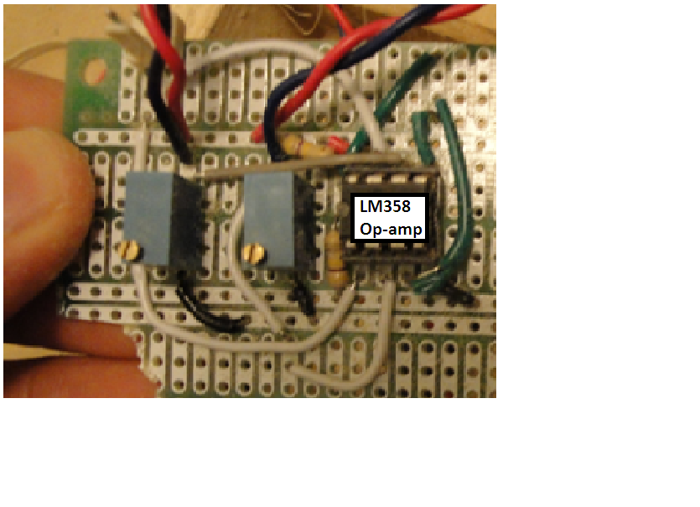

Fig.4.2.2.15:

#### 4.2.2.9 LED circuit

Two 3W LEDs are required across the dowel reservoir opposing the light photo-resistors in order to enable the photo-resisters as well as to minimize environmental lighting effects. The voltage requirement for the LEDs is 3.6v – 4.2v, the required heat sink is attached to the LEDs at purchase. To achieve the required voltage, the simplest method is used. A trimmer resistor is connected in series with the LED thus reducing the voltage, a 3.9v Zener diode is used for voltage regulation purposes. The LED driver (one of the two) is shown in FIG 4.2.2.16.



Figure 4.2.2.16: LED driver

#### 4.2.2.10 Emergency stop

As it can be seen from Fig.4.2.2.3, a physical switch acting as the emergent stop is installed at the output of the ground connector from the power supply. Once pressed, all electrical components including the PIC controller will be cut and no mechanical components will be moving. This approach is implemented onto this machine for its easiness of installation and limited time duration of the working period, yet better solutions are discussed in the improvement section.

#### 4.2.2.11 Connection between PCBs

Connections are required between different PCBs for both power supply and signal transmission. All PCB connections in this project are implemented using the male stands on the PCBs with female connectors attached to the jumper wires (both available from Home Hardware). Two things should be noted for this type of connection: 1) The sire heads cannot be stripped to be too long as it may lead to short circuit between adjacent connectors; 2) It is better to solder the metal connector onto the wires to ensure the connector is electrically conductive. Another common alternative approach for PCB connections is to use the plug-and-pull jumper wires with female heads at both ends as. This type of jumper wire is more flexible to debug during the construction process yet it is 3 times more expensive comparing to the former approach. As a consequence, the former plastic jumper connectors are chosen in order to satisfy the budget constraint.

### 4.2.3 Simulation Results

All transducer and motor driver circuits are first simulated on the solderless breadboard to ensure correct circuit design and connections before they are soldered PCBs. Some of the simulation results are recorded and uploaded onto YouTube as listed below:

Stepper motor: <http://www.youtube.com/watch?v=GvvB47G9LsU>

Bi-directional motor: <http://www.youtube.com/watch?v=GCDtVIuRFfQ>

Uni-directional motor: <http://www.youtube.com/watch?v=BEHMhXCGero>

Proximity sensor: <http://www.youtube.com/watch?v=pLJGnLsT2Yo&feature=youtu.be>  
[[6](#You13)]

And the current requirement for each sub-components are listed below:

|  |  |  |
| --- | --- | --- |
| Component | Functional Voltage | Required Current |
| PIC Controller | 12V | <0.17A |
| Relay | 5V |  |
| Rotating Cylinders (2 DC motors) | 5V | <0.7A\*2=1.4A |
| Box Loader (1 DC motor) | 5V | <0.2A |
| Dowel Pushers (2 DC motors) | 5V | <0.3A\*2=0.6A |
| Stepper Motor | 12V | <0.21A |
| Proximity Sensor | 5V | <0.005A |
| Light Sensor \*2 | 5V | <0.01A |
| LEDs \*2 | 5V | <0.35A\*2=0.7A |
| ICs and buffers | 5V | <0.1A |
| Emergency stop | N/A | 0 |

Table 4.2.3.1: Detailed breakdown current calculations for both 5V and 12V power supply

Furthermore, it is also ensured during the simulation process that currents of all outputs from and inputs into the PIC controller are less than its current rating of 25mA for each pin.

### 4.2.4 Current Calculations

As it is shown in Fig. 4.2.3.1, the maximum current required for the 5V power supply occurs when the dowel pusher and rotating cylinders operate at the same time which turns out to be 2.7A. The maximum current required for the 12V power supply equals to the sum of conveyor belt and the PIC controller, which turns out to be 0.34A. Since both the 5V and 12V current required are smaller than the limitations of the power supply provided in the design kit, it can be concluded that it is safe to use the power supply provided to power this machine.

### 4.2.5 Power Calculations

According to the simulation result shown in Fig. 4.2.3.1, the maximum power consumption of this machine occurs when dowel pusher and rotating cylinders operate at the same time, and it can be calculated by

$P=I∙V=5V*2.7A+12V*0.17A$ =15.54W

### 4.2.6 Suggestions for Improvement of the Subsystem

1. **Voltage Regulator**

Due to the time duration limitation of this project, voltage regulators are not installed although the design team recognizes its potential to provide a constant voltage power supply. The usage of voltage regulators is not a necessity when using the AC power adaptor from the design kit as it is able to provide a voltage constant enough for the machine to be functional. However, when using batteries to power this machine, LM7805 (datasheet attached in Appendix E) and LM7812 voltage regulators should definitely be installed for the +5V and +12V voltage sources as voltage provided by batteries fluctuates a lot depending on the current required. The detailed circuit diagram is shown in Fig. 4.2.6.1, and it shall be installed directly to the output of the power supply.

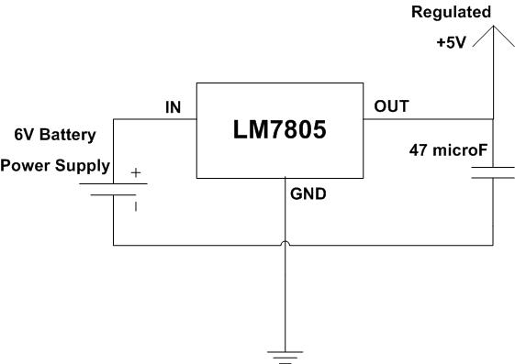  
Figure 4.2.6.1: Detailed circuit diagram

1. **Fuse**

During the construction and testing process of this machine, two TAKAMISAWANA5W-K relays (Appendix J) and one KP48FP8G-504 stepper motor have been burnt due to short circuit in the connecting wires. In order to avoid burning other electrical components in the system, two fuses shall be implemented at both the +5V end and +12V end. In particular, according to the current calculation above, a 5V 5A fuse shall be installed along the +5V line and a 12V 2A fuse for the +12V line.

1. **Emergency Stop**

As described previously, the emergency stop is implemented using a physical switch directly connected to the ground line, which is the easiest and least time-consuming approach. However, a more considerate approach is to connect the emergency stop directly to a pin on the PIC controller interface so that once pressed, an interrupt will be evoked to stop all moving mechanical components by setting all motors to stop mode via the PIC controller. In that way, the machine can resume its function once the emergency button is pressed out and no operating information will be destroyed or lost.

## 4.3 PIC Microcontroller

### 4.3.1 Assessment of Problem

The PIC microcontroller is responsible for bringing together the circuit and mechanical parts of the machine as well as providing the logic of operation. In specific, the microcontroller is responsible for the following

1. Provide an User Interface, which includes keypad and LCD functionality
2. Handles user commands through keypad
3. Provide RTC functionality through I2C protocol
4. Provide EEPROM functionality to store logs
5. Provide logic and control for dowel packing (FSM)
   1. Allow users to add patterns to be packed
   2. Provide brushed DC motor control for dowel sorters and box loader
   3. Provide bi-directional motor control for dowel pushers
   4. Provide unipolar stepper motor control (high power firing sequence) for conveyor belt
   5. Set up and handle PORTB external positive edge-triggered interrupt for dowel counting

### 4.3.2 Programming Solutions

#### 4.3.2.1 Overview

The program is designed to be modular, subroutines and functions are written separately and tested separately. High-level C-style pseudo code is attached below

// Modules that are in all-capitals are the main logical functions

// These modules control the operation of the entire process

// Sudocode is in C style

#define display printf

**void** IDLE(){

**while**(key\_pressed = scan\_keyboard()){

**switch**(key\_pressed){

**case** 1:

OPERATION();

**break**;

**case** 2:

VIEW\_LOG();

**break**;

**case** 3:

ADD\_REQUEST();

**break**;

**case** 4:

CURRENT\_STATUS();

**break**;

**default**:

}

}

}

**void** OPERATION(**void**){

**if**(queue is empty){

**return**;

}

**while**(queue is not empty){

**while**(box is not in position) move\_box\_to\_position();

operation = dequeue();

**switch**(operation){

**case** 1:

PATTERN\_FSM\_1();

**break**;

**case** 2:

PATTERN\_FSM\_2();

**break**;

**case** 3:

PATTERN\_FSM\_3();

**break**;

**case** 4:

PATTERN\_FSM\_4();

**break**;

**case** 5:

PATTERN\_FSM\_5();

**break**;

**case** 6:

PATTERN\_FSM\_6();

**break**;

**default**:

assert(queue\_error);

}

update\_EEPROM();

}

unload\_boxes();

TERMINATION();

}

**void** PATTERN\_FSM\_3(**void**){

load\_dark();

move\_slot();

load\_dark();

move\_slot();

load\_dark();

move\_slot();

load\_light();

move\_slot();

load\_light();

move\_slot();

load\_light();

}

**void** VIEW\_LOG(**void**){

display\_log();

**while**(operation = scan\_keypad()){

**if**(direction == **return**) **return**;

**if**(direction == previous and previous log exists){

display\_prev\_log();

**continue**;

}

**if**(direction == next and nextlog exists){

display\_next\_log();

**continue**;

}

display("log does not exist");

}

}

**void** ADD\_REQUEST(**void**){

**while**(request = scan\_keypad()){

**if**(queue is full){

display("queue is full");

**break**;

}

**switch**(key\_pressed){

**case** 1:

enqueue\_1();

**break**;

**case** 2:

enqueue\_2();

**break**;

**case** 3:

enqueue\_3();

**break**;

**case** 4:

enqueue\_4();

**break**;

**case** 5:

enqueue\_5();

**break**;

**case** 6:

enqueue\_6();

**break**;

**default**:

display("Invalid choice, try again");

}

}

}

**void** CURRENT\_STATUS(){

display(CUR\_STAT);

}

**void** TERMINATION(){

**while**(choice = scan\_keypad()){

**switch**(choice){

**case** 0: **return**;

**case** 1:

display(info1);

**break**;

**case** 2:

display(info2);

**break**;

**case** 3:

display(info3);

**break**;

**case** 4:

display(info4);

**break**

**case** 5:

display(info5);

**break**

**default**:

**break**;

}

}

}

The actual assembly code closely follows the above pseudo code, modifications and improvements are added where appropriate.

#### 4.3.2.2 User Interface

The user interface displays information on a LCD, keypad functionality is also include so that users can operate the machine. The UI is designed to be user-friendly, instructions are clear and users can navigate through various options with ease. High-level pseudo code is shown below

**void** IDLE(){

**while**(key\_pressed = scan\_keyboard()){

**switch**(key\_pressed){

**case** 1:

OPERATION();

**break**;

**case** 2:

VIEW\_LOG();

**break**;

**case** 3:

ADD\_REQUEST();

**break**;

**case** 4:

CURRENT\_STATUS();

**break**;

**default**:

}

}

}

The actual implementation first displays a power-on message followed by a short delay (figure 4.3.2.1).

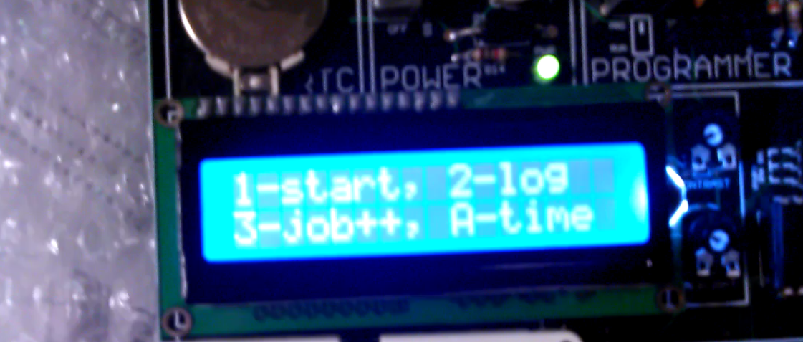  
Figure 4.3.2.1: Power-on message

The LCD screen (Figure 4.3.2.2) is then cleared by calling Clear\_Display function, a default message is displayed for users to choose whether to 1- Start operation, 2- View log, 3- Add job, or 4- View time. 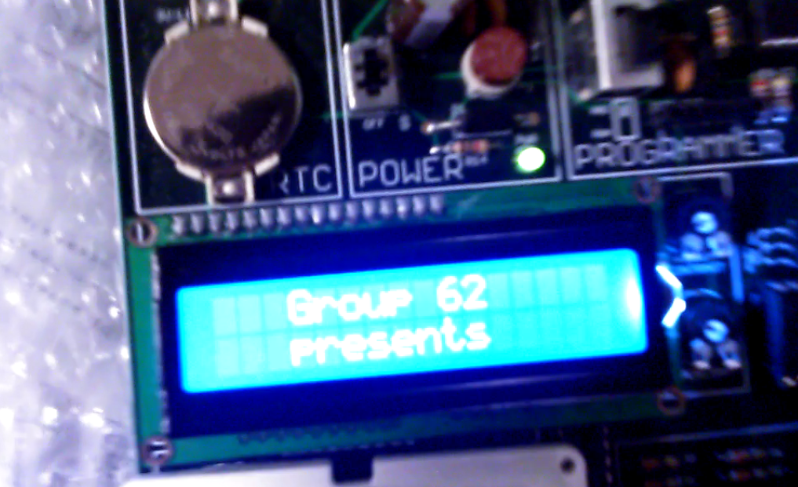

Figure 4.3.2.2: LCD screen

The program then calls appropriate key handlers. Keypad functionality is made possible by calling the function GET\_INPUT

GET\_INPUT

T1 **btfss** PORTB,1

;Wait until data is available from the keypad

**goto** T1

**NOP**

**swapf** PORTB, WREG ;Swap nibble and store in WREG

**NOP**

T2 **btfsc** PORTB,1 ;Wait for user to release key

**goto** T2

**andlw** 0x0F

**return**

This function stores the keypad input into WREG as a HEX number. Main loop checks which key is pressed by polling on keypad, then appropriate key handlers are called. Example of KEY\_2 checker and KEY\_2 handler assembly code is shown below

SKIP\_1

**CPFSEQ** KEY\_2 ; KEY\_2 contains 0x01

**goto** SKIP\_2

**call** KEY\_2\_HANDLER

**clrf** WREG

**CPFSEQ** KEY\_2

**goto** SKIP\_2

**goto** INPUT\_LOOP

Associated KEY\_2\_HANDLER function:

KEY\_2\_HANDLER

**clrf** EEPROM\_H

**clrf** EEPROM\_L

**call** EEPROM\_READ ;Get the number of logs

**movwf** LOG\_NUM

READ\_LOG\_LOOP

**decfsz** LOG\_NUM ;Loop through all the logs

**call** VIEW\_REQUEST

**call** DELAY1S

**call** DELAY1S

**goto** READ\_LOG\_LOOP

**return**

#### 4.3.2.3 RTC Functionality

The RTC functionality is achieved using an on-board DS1307 RTC chip with 3V 3025 lithium battery. The <i2c\_common.asm> includes all the required low-level communication code associated with I2C protocol. <rtc\_macros.inc> is the header file for macros rtc\_read, rtc\_set, rtc\_resetAll. The rtc\_set function is used only once to reset the RTC chip, and subsequent functions will run on a previously-known time. RTC is also used to find the operation time by comparing the RTC readings before and after the operation, which takes into account possible cross-hour, cross-day or cross-year operations (for example, if the operation is performed on 2013 December 31st 11:59PM and finished on 2014 January 1st 12:01 AM). VIEW\_TIME function (invoked in UI by pressing A) is implemented using the RTC, UI pseudo code case 4 is shown below

**case** 4:

CURRENT\_STATUS();

**break**;

The RTC set and read functions are shown below

SET\_TIME

rtc\_resetAll ;reset rtc

rtc\_set 0x00, B'10000000'

;set time

rtc\_set 0x06, B'00010011' ; Year 2013

rtc\_set 0x05, B'00000100' ; Month 4

rtc\_set 0x04, B'00001111' ; Date 9

rtc\_set 0x03, B'00000010' ; Day 2 (tue)

rtc\_set 0x02, B'00100001' ; Hours 21

rtc\_set 0x01, B'00000000' ; Minutes 0

rtc\_set 0x00, B'00000000' ; Seconds 0

**return**

RTC\_GET\_TIME

rtc\_read 0x06 ;Year

**movff** 0x75, RTC\_YEAR

**call** PRINT\_NUM

rtc\_read 0x05 ;Month

**movff** 0x75, RTC\_MONTH

rtc\_read 0x04 ;Date

**movff** 0x75, RTC\_DATE

rtc\_read 0x02 ;Hour

**movff** 0x75, RTC\_HOUR

rtc\_read 0x01 ;Minute

**movff** 0x75, RTC\_MIN

rtc\_read 0x00 ;Second

**movff** 0x75, RTC\_SEC

**return**

#### 4.3.2.4 EEPROM read and write

The on-chip EEPROM is used to store permanent logs of operations, information stored includes packed pattern and operation time. The memory is organized as follows

|  |  |  |  |  |  |  |  |  |  |
| --- | --- | --- | --- | --- | --- | --- | --- | --- | --- |
| Address | Log number | Bit7 | Bit6 | Bit5 | Bit4 | Bit3 | Bit2 | Bit1 | Bit0 |
| 0x00 |  | Number of logs stored in EEPROM (in binary) | | | | | | | |
| 0x01 | 1 | Pattern #2 | | | | Pattern #1 | | | |
| 0x02 | Operation time (second) # 2 | | | | Operation time (second) # 1 | | | |
| 0x03 | Operation time (10 sec) # 2 | | | | Operation time (10 sec) # 1 | | | |
| 0x04 | Operation time (minute) # 2 | | | | Operation time (minute) # 1 | | | |
| 0x05 | 2 | Pattern #2 | | | | Pattern #1 | | | |
| 0x06 | Operation time (second) # 2 | | | | Operation time (second) # 1 | | | |
| 0x07 | Operation time (10 sec) # 2 | | | | Operation time (10 sec) # 1 | | | |
| 0x08 | Operation time (minute) # 2 | | | | Operation time (minute) # 1 | | | |
| 0x09 | 3 | Pattern #2 | | | | Pattern #1 | | | |
| 0x0A | Operation time (second) # 2 | | | | Operation time (second) # 1 | | | |
| 0x0B | Operation time (10 sec) # 2 | | | | Operation time (10 sec) # 1 | | | |
| 0x0C | Operation time (minute) # 2 | | | | Operation time (minute) # 1 | | | |

To read and write from and to EEPROM, recommended assembly code from data sheet is followed, EEPROM\_READ and EEPROM\_WRITE functions are shown below.

EEPROM\_READ

**clrf** EEDATA

**movf** EEPROM\_H, WREG

**movwf** EEADRH ; Upper bits of Data Memory Address to read

**movf** EEPROM\_L, WREG

**movwf** EEADR ; Lower bits of Data Memory Address to read

**bcf** EECON1, EEPGD ; Point to DATA memory

**bcf** EECON1, CFGS ; Access EEPROM

**bsf** EECON1, RD ; EEPROM Read

**movf** EEDATA, WREG ; W = EEDATA

**return**

EEPROM\_WRITE

**bcf** INTCON, GIE ; disable interrupt

**bcf** EECON1, EEPGD ; Point to DATA memory

**bcf** EECON1, CFGS ; Access EEPROM

**bsf** EECON1, WREN ; Enable writes

**movf** EEPROM\_H, WREG ;

**movwf** EEADRH ; Upper bits of Data Memory Address to write

**movf** EEPROM\_L, WREG ;

**movwf** EEADR ; Lower bits of Data Memory Address to write

**movf** EEPROM\_DATA, WREG; Data to be written -> WREG

**movwf** EEDATA ; Data Memory Value to write

; do not modify the following

**movlw** 55h ;

**movwf** EECON2 ; Write 55h

**movlw** 0AAh ;

**movwf** EECON2 ; Write 0AAh

**bsf** EECON1, WR ; Set WR bit to begin write

; do not modify the above

EE\_WAIT2

**btfss** PIR2, EEIF

**goto** EE\_WAIT2

**bsf** INTCON, GIE ; If interrupt was enabled, enable interrupts

**bcf** EECON1, WREN ; Disable writes on write complete (EEIF set)

**return**

EEPROM is updated whenever a run is completed (with either one or two jobs added, if only one job is added, pattern 2 is read 0x00).

#### 4.3.2.5 Logic control for packing operations

The main logic follows the pseudo code, which is shown below

**void** OPERATION(**void**){

**if**(queue is empty){

**return**;

}

**while**(queue is not empty){

**while**(box is not in position) move\_box\_to\_position();

operation = dequeue();

**switch**(operation){

**case** 1:

PATTERN\_FSM\_1();

**break**;

**case** 2:

PATTERN\_FSM\_2();

**break**;

**case** 3:

PATTERN\_FSM\_3();

**break**;

**case** 4:

PATTERN\_FSM\_4();

**break**;

**case** 5:

PATTERN\_FSM\_5();

**break**;

**case** 6:

PATTERN\_FSM\_6();

**break**;

**default**:

assert(queue\_error);

}

update\_EEPROM();

load\_box();

}

unload\_boxes();

TERMINATION();

}

During the FSM operations, there will be sanity checks before dowels are pushed out of the magazines. If dowel sorters haven’t sorted out a light dowel or a dark dowel, a light / dark dowel will not be pushed and the program will halt until a dowel is sorted. This is accomplished in the program by calling the function WAIT\_LIGHT and WAIT\_DARK before calling PUSH\_LIGHT and PUSH\_DARK. The functions WAIT\_LIGHT checks if the variable LIGHT\_COUNTER is zero, if so, program halts until an interrupt increments LIGHT\_COUNTER. Also, whenever a light dowel is pushed out LIGHT\_COUNTER decrements by 1. This makes the variable LIGHT\_COUNTER and DARK\_COUNTER the number of dowels remaining in the reservoirs. A simplified state diagram for only 2 dowels (light followed by a dark dowel) is shown below. Upon calling PATTERN\_FSM\_X functions, the conveyor belt will rotate to move the empty box forward until a proximity sensor detects the presence of the box. Polling method is used to read sensor data due to the fact that checking proximity sensor data is the only task that the PIC has during that period, thus interrupt / other methods that frees PIC from polling is excessive.

C:\Users\Kang\Desktop\PIC18F4620\Final_report\FSM.emf

Mechanically, a Light Dependent Resistor (LDR) is placed on the side of the dowel tracks. The LDR is in series with a trimmer resistor, which is also part of the comparator OP-AMP module that detects a change in light intensity received by LDR. Whenever a dowel is sorted, it must also block the LDR thus generate a positive edge signal which will then generate an external interrupt in the PIC. PIC’s ISR will then increment LIGHT\_COUNTER and DARK\_COUNTER accordingly.

##### 4.3.2.5.1 Dowel counting

Dowel counter is implemented using interrupt, where an interrupt is generated when a dowel falls down along the track and blocks the LDR, which then generates a positive edge on pins RB0 and RB1. Upon interrupt, the program will increment the variables DARK\_COUNTER or LIGHT\_COUNTER according to the pin that generated interrupt (RB0 for dark dowels and RB1 for light dowels). The mechanical setup of dowel counter is described in details in section “Electromechanical”. The ISR code is as follows:

ISR

**btfsc** INTCON, INT0IF ;Check if INT0 has interrupted

**incf** DARK\_COUNTER

**btfsc** INTCON3, INT1IF ;Check if INT2 has interrupted

**incf** LIGHT\_COUNTER

END\_ISR

**bcf** INTCON, INT0IF ;Clear interrupt

**bcf** INTCON3, INT1IF ;Clear interrupt

**return**

Another significant function of the dowel counter is to prevent dowel pusher from pushing on an empty dowel magazine.

#### Dowel sorting:

The PIC microcontroller directly controls the two brushed DC motors that rotates dark and light dowel sorters. The motors are not PWM’ed due to the high torque requirement when all 12 dowels are placed inside. Sorters are turned on when user presses “Start” button, and is turned off when the operation is completed. The complete code is shown below, where RB7 is used to control the sorter of both light and dark dowel sorters.

;\*\*\*\*\*\*\*\*\*\*\*\*\*\* Dowel sorter \*\*\*\*\*\*\*\*\*\*\*\*\*\*\*\*\*\*\*\*\*\*\*\*\*\*\*\*\*

CYL\_ON

**bsf** PORTB, 7

**return**

CYL\_OFF

**bcf** PORTB, 7

**return**

#### 4.3.2.5.2 Dowel pusher:

We have decided to use two bi-directional brushed DC motor as the dowel pusher. There’re four pins controlling the dowel pushers, two pins for direction and two pins as enable pins. Due to the work load difference of the two motors (dark dowels are harder to push than light dowels) as well as the work load difference for the same motor between extension and contraction (greater force is needed to push the dowels out), therefore delay values for light / dark dowel push / pull are different and thus need fine adjustments after the completion of the program. This modular design requires fine adjustments; however, it also made modifications easier. A stronger motor requires only shorter delay; larger gear ratio also requires only changes in delay values. The fact that the programming is extremely flexible assists in the modularity of the design as a whole.

#### Conveyor belt (stepper motor control):

We have experimented with low and high power firing sequences, and due to the torque requirements, high power firing sequence was used. Four pins are connected to the stepper motor (through driver), and the following sequence is used for forward rotation:

**1001 ------ 1010 ------ 0110 ------ 0101**

High power firing sequence produced enough torque to rotate the conveyor belt with two fully-loaded boxes.

### 4.3.3 Suggestions for Improvement of the Subsystem

There are several places where the program can be improved.

1. Timer interrupt instead of hard-coded delay function can be used
2. Emergency stop interrupt
3. PC interface

#### 4.3.3.1 Timer interrupt

Timer interrupt should be used instead of clock cycle counting (polling) method. Interrupt frees up the PIC from doing useless work (polling) and thus increases the efficiency of the program.

#### 4.3.3.2 Emergency interrupt

Instead of cutting the main power supply, emergency button should be set up as an interrupt where user can choose to resume the operation. Detailed explanations see circuit section improvements.

#### 4.3.3.3 PC interface

A PC interface should be added to the program. It give the user more information than on an LCD, also allows direct communication between PIC and users, bypassing the complication of printing ASCII characters on LCD.

#### 4.3.3.4 Calculations and Simulation

Simulations are done by mimicking sensor inputs in devbugger. This is accomplished by flipping the microswitches, which is then read into the PIC as sensor inputs. This method is particularly useful in pre-integration debugging where sensor inputs are not available.

##### 4.3.3.4.1 Calculations for 0.1 second delay

4MHz crystal => 10,000 instruction cycles is 0.1 second. Delay code generator available at [www.piclist.com/cgi-bin/delay.exe](http://www.piclist.com/cgi-bin/delay.exe) is used for this calculation.

**SEE APPENDIX FOR COMPLETE SOURCE CODE AND PSEUDO CODE**

# 5 Integration

### 5.1 Integrate individual actuators with PIC controller

There are in total six actuators, of the six, five were powered by brushed DC motor and one is by stepper motor. Integration with actuators had several problems, which were debugged and fixed.

1. DC motor delay were different on different motors although they were the same in software
2. Stepper motor sometimes does not run properly
3. Gear came out of some motors

#### Solutions to problem 1:

We first fixed the problem by adjusting individual delay values. We used timer delay for all delays, adjusting the delay value worked well. However, there seem to be a problem when multiple motors share one timer, the actual delay time was unpredictable for some reason, a small change in delay value resulted in a huge change in delay time, and vice versa. We then consulted Professor Emami, and the problem turns out to be that timers cannot be used to have multiple delay values, thus a new solution is needed to either use more timers or else. We then decided that the top priority was to finish integration instead of the elegancy of the code, therefore a polling counting timer was used, which was effective and solved the problem.

#### Solutions to problem 2:

Stepper motor was running perfectly during most part of the system integration, however at one point it suddenly failed to work. The motor either jerks and does not rotate or rotates but changes direction when resistance is encountered. After several hours of debugging, the conclusion was that we had a broken stepper motor. We replaced the motor and nothing changed, we then tried replacing the wires which fixed the problem.

#### Solutions to problem 3:

When we fabricated the motor-gear attachment, we simply drilled a whole at the center of the gear, and superglued it onto the shaft of the motor. The adhesion was not enough to overcome the torque exerted on the shaft. We tried several methods to fix this problem. We began by using epoxy instead of superglue to connect the gears to the shaft with success, but the gears came off after a while. We then tried drilling a smaller hole on the gear and force the gear onto the shaft by hammering it down. This method worked well and successfully solved the problem, it used in all subsequent fabrications.

### 5.2 Integrate sensors and transducer values with PIC controller

We used proximity sensors and LDRs as light sensors. Integration began by checking the 8-to-3 converter for proximity sensors, which was routed correctly. Sensors were checked individually and as an array of 8. There were several problems discovered during integration and testing of proximity sensors, and light sensors all worked as expected.

1. Proximity sensor sometimes does not detect an object that blocks it
2. The 8-to-3 converter with 8 sensors in inaccurate and fluctuates too much to be trusted to detect the position of the box.
3. On one occasion the power supply is shorted whenever the sensor board is plugged in.

#### Solution to problem 1:

We have tried many ways to fix the first problem and none seemed especially effective even to this date. We first tried solving the problem by adjusting the distance between the sensors and object. Datasheet recommended the distance to be 3-5 centimeters, and we tried in the range of 2-10 centimeters with no successes. We then tried to adjust the angle that the sensors points at. In order to adjust all 8 sensors at once, we first mounted the sensors onto a foam bar. However we accidentally shorted the circuit which caused us some trouble to debug. Eventually we were able to mount the sensors onto a wood bar and precisely control the angle at which it points at. This method was effective for position 000, 001, 010, 011 and 100, after which the sensor-converter complex had unpredictable behaviours. This problem was not solved until a change in design occurred which ruled out 7 out of the 8 sensors. The change in design will be discussed in solution to problem 2.

#### Solution to problem 2:

As mentioned before, the sensor-converter complex was not working properly due to reasons we do not understand, most likely due to electrical noises (lots of wires connecting the logic gates). Since we chose to use stepper motor to drive the conveyor belt, we decided to take full advantage of it and reduce the number of sensors to one. Once the position of the box is known (proximity sensor detects a box), position can they be controlled precisely by stepper motor. This method was proven to be effective and we discontinued the use of 8-to-3 signal converter.

#### Solution to problem 3:

After debugging, it was determined that some pins were soldered too closely together, we re-soldered those pins and trimmed the longer wires. The problem was solved with success. It was later determined that not only the sensor boards, but other boards suffered similar problems. We re-soldered pins and trimmed wires to make them less likely to short the circuit.

### 5.3 Fixation of actuators and transducers

Actuators and transducers are required to be mounted onto the mechanical frame in order for the mechanical components to be functional, and in particular, it includes the following electrical components:

1. Stepper motor

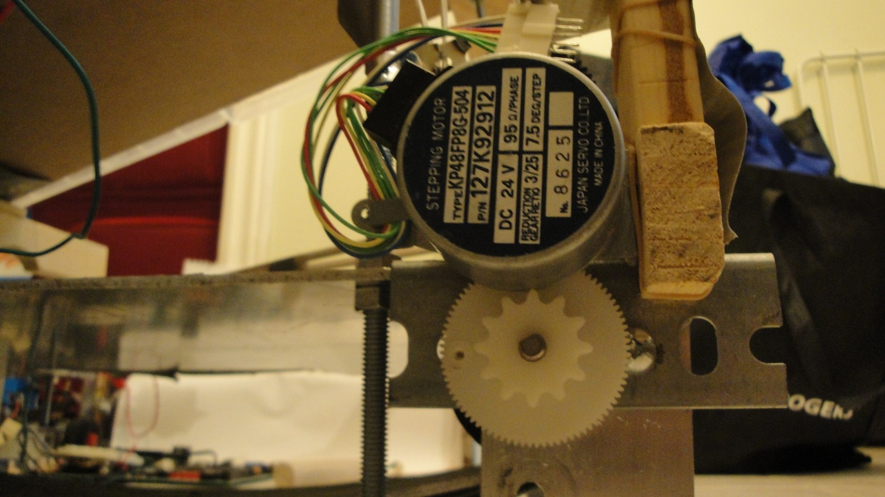Figure 5.3.1: Stepper motor attached to conveyor belt

The stepper motor that controls the conveyor belt was launched on the leg of the conveyor closest to the axel controlling the motion (figure 5.3.1). The dc motors for the dowel sorters are placed right beside the sorters as there is ample space at the top of the machine. They are connected to the frame supporting the sorters. The final motors that are used as linear actuators used to push dowels out of the reservoir into the box on the conveyor belt. The gears of the motors are attached by drilling a hole and applying super glue which is effective between plastics.

$Power = 2π*torque*RPM$ (Equation 1)

The power requirement for the conveyor belt and rotating cylinders came out to 1.23 W by using equation 1. The rotations per minute were 60. And the torque is 3.26mN.

1. Dowel pusher DC motors

Two dowel pusher DC motors are installed right next to the dowel container (figure 5.3.2), and they are glued and screwed onto a piece of wooden block in order to prevent it being lifted up from the gear linear actuator below it.

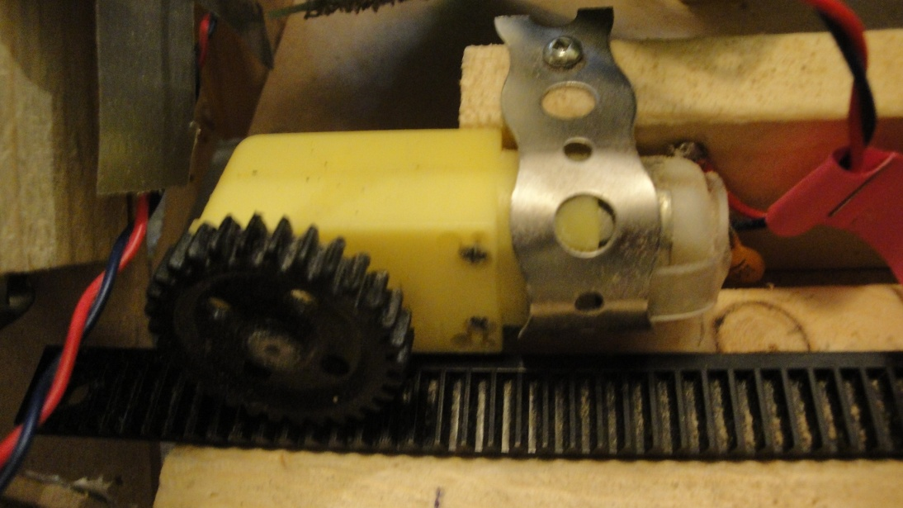

Figure 5.3.2: Dowel pusher fixation using wood glue and screws over a metal piece

1. Rotating cylinder DC motors

These two rotating cylinder DC motors are the hardest to fix as they require the largest force to hold it due to interacting pushing force between the dowels when the cylinder rotates. Since none of the adhesives available is strong enough, two L brackets are installed using eproxy to increase its contacting area.

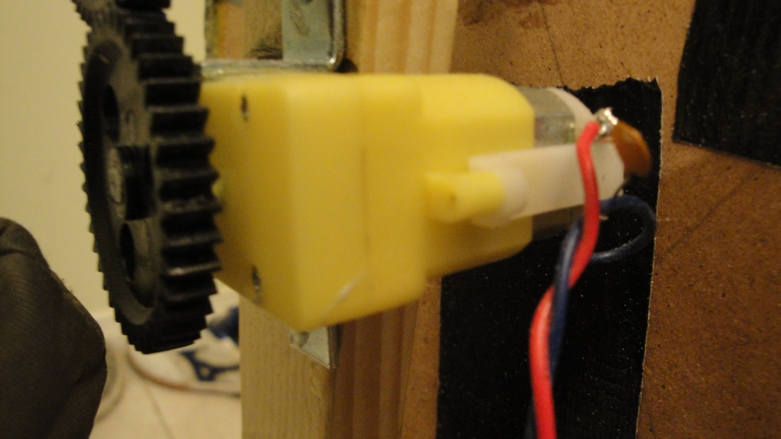

Figure 5.3.3: DC motors for the rotating cylinders

1. Proximity Sensor

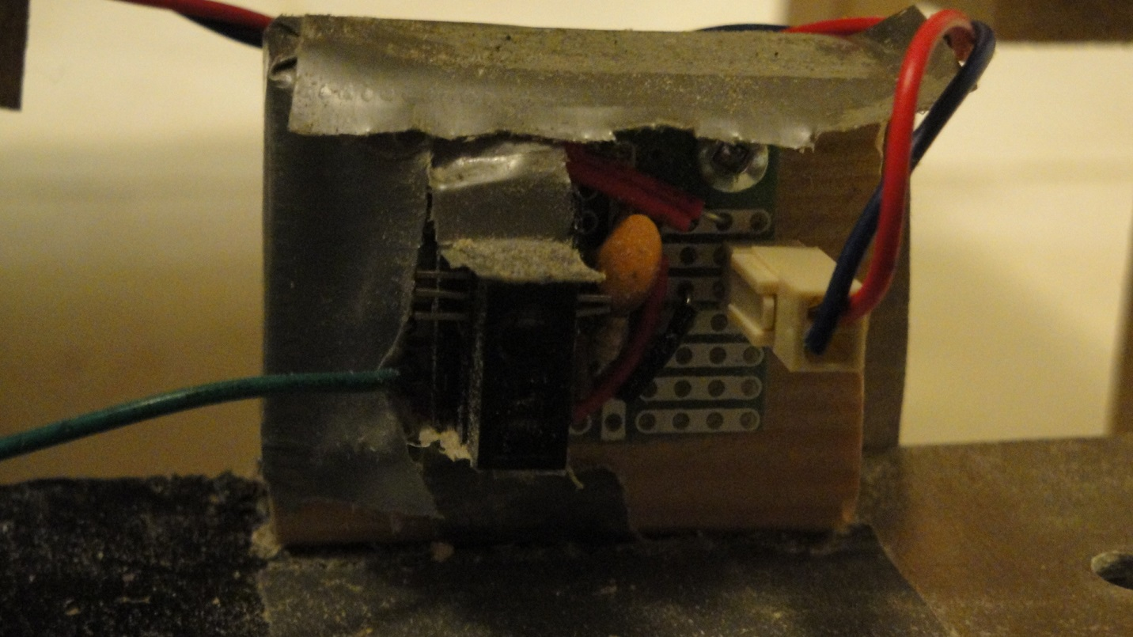Figure 5.1.3.4: Proximity Sensors Fixation

The proximity sensor PCB is screwed onto a piece of wood which is in turn glued onto the aluminum base using eproxy. Screw is chosen to attach the PCB to the wooden block so that its orientation can be adjusted to ensure it is aligned with the box.

### 5.4 Fixation of circuit boards and PIC controller

The circuits and PIC microcontroller were placed on a stand that held the reservoirs as shown in Figure 5.4.1. There was an abundance of space to hold all the circuits and it was easily coverable if needed to be. The space under the reservoirs also provided a connection between the circuits on the reservoir stand and the motors and sensors attached to the conveyor.

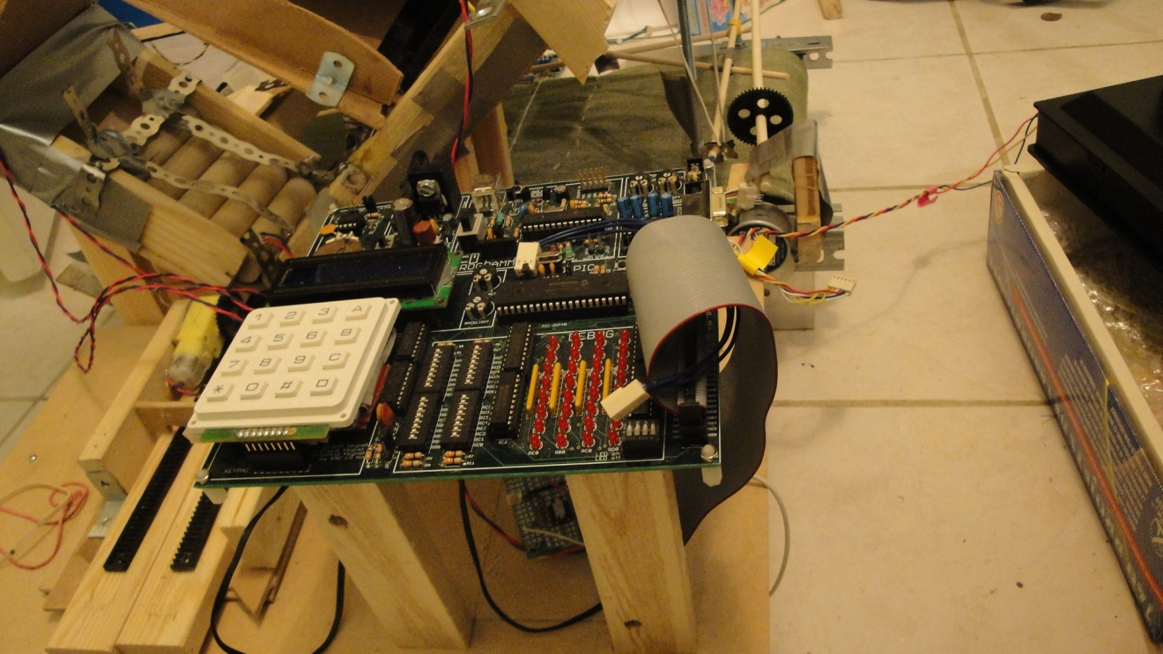

Figure 5.4.1: Fixation of the PIC controller

# 6 Accomplished Schedule

Green, Red, Pink, Yellow – Predicted

Blue, Cyan, Violet, Purple - Actual

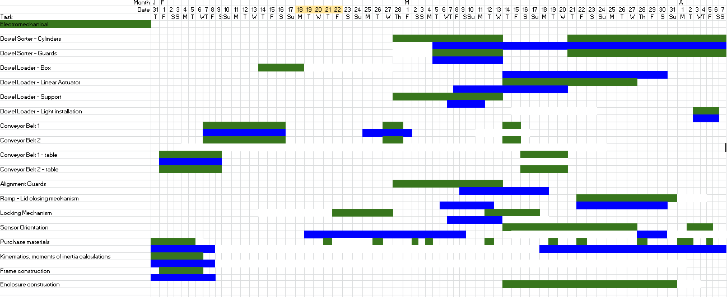

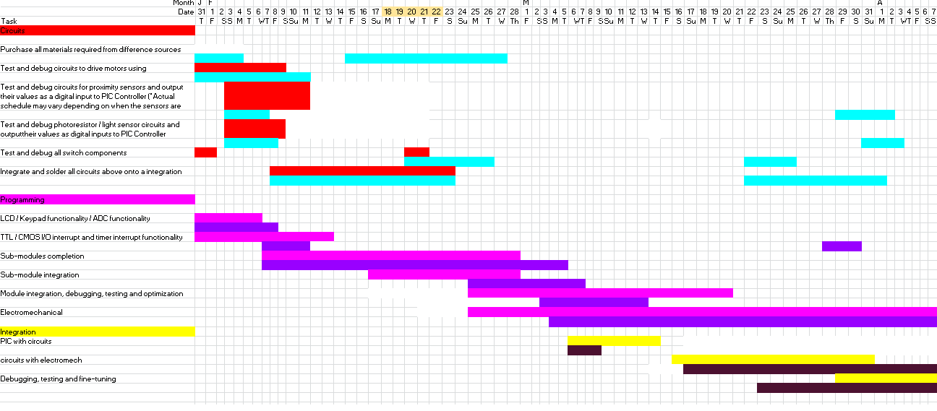

# 7 System Improvement Suggestions

The overall system of the machine once integrated can be improved in three specific areas to provide a much better performance:

1. Weight

As mentioned earlier, the weight of the system was very close to the maximum limit. This restricted any possibility of extra features to be added onto the machine. To improve the system, light material should be used as mentioned in section 4.1.3.

1. Dowel Sorter

The dowel sorter was not nearly as efficient as expected. An improvement to this design would be to increase the size of the container allowing for a bigger volume for dowels to become aligned. This might not work perfectly and an alternative reference design should be considered.

1. Safety

The machine had many sharp corners and loose wires. Although there is a specific place where wires and the PIC are located, it was not covered and could be easily damaged. In addition, there are many aspects that can make the mechanical design safer for users. By sanding down sharp edges and blunting connections, it can reduce the potential for injury.

# 8 Description of Overall Machine

The entire system is situated on 8 legs that house two major platforms, circuits and conveyor, which can be joined and detached easily. The storage capability of the machine is 12 dowels and 3 boxes adhering to the constraints given.

The machine consists of 4 DC motors located on the sorters and dowel pushers and 1 stepper motor situated on the leg of the conveyor belt system closest to the axel of rotation. The PIC is located above the circuits’ platform on its own level.

The conveyor system moves the boxes from the box loader situated above the conveyor platform to the pickup area. The sorting mechanism is situated directly above the reservoirs on the circuits’ platform.

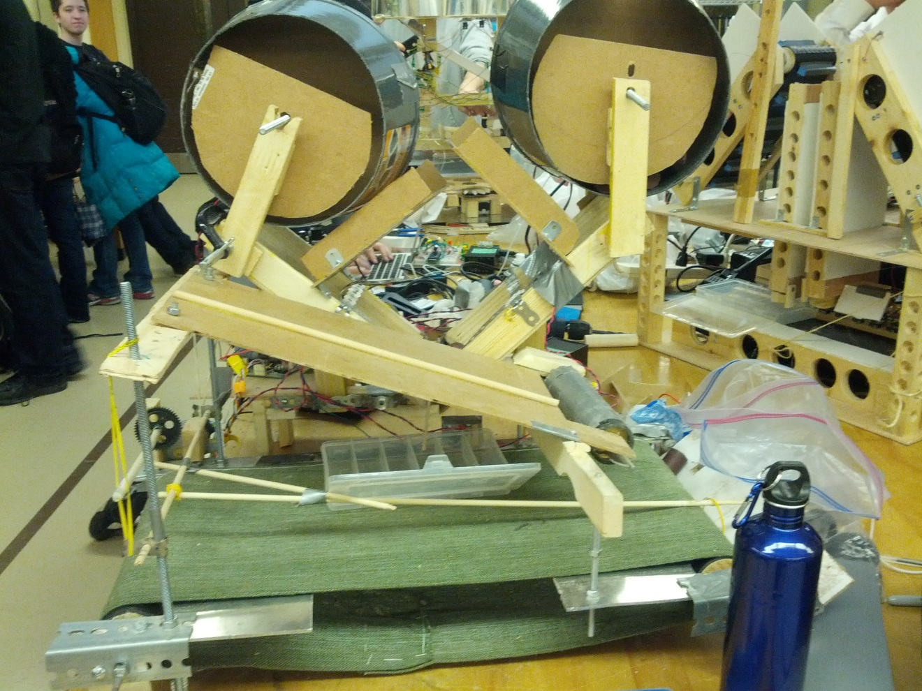  
Figure 8.1: Overall machine

# 9 Standard Operating Procedure

Initially dowels are entered into the sorting mechanism. Once sorted, dowels enter the reservoir and wait to be packed into the boxes.

The box loader loads a box on the conveyor belt and operation begins once the dowels are sorted.

In the midst of the conveyor travel, the dowel pushers put dowels in the respective spots in the box. This is done by a proximity sensor timer interface that predicts which position the box is at a given time initializing after the box passes the sensor.

Finally the lid is closed by a ramp mechanism right before the pickup area.

# 10 Conclusion

The dowel packer machine was moderately successful. All subsystems were manufactured individually and were integrated together. Among the five sub-problems divided **previously**:

Dowel-aligning/sorting functions 60-70% of the time for less than eight dowels placed in ANY orientation yet it is unable to rotate when 12 dowels are placed in due to the lack of the torque as shown <http://www.youtube.com/watch?v=RQWL3RG14R4>

Box loader is able to load the box onto the conveyor belt one-by-one, yet the dropping process creates some degree of randomness and its position may sometime be too far for the proximity sensor.

Dowel loading using the linear actuator powered by a bidirectional DC motor is able to work consistently.

Pattern select and packing work consistently and accurately.

Box unloading and lid-closing mechanisms work consistently and accurately provided that at least two dowels are inserted into the box. However, the lid-closing mechanism requires more adjustment.

In terms of improvement, the most urgent change is to use a DC motor with a greater torque or gear the motor down to provide enough torque for the cylinder to rotate in order to qualify. Besides that, fuses should be installed in place to prevent the machine from burning other electrical components.

Unfortunately due to the inability of the sorter to sort 12 dowels in time, the procedure could not complete the run under the time constraints of 2 minutes. The areas for improvement involve speed and size of sorting.

In terms of speed of the sorter, it can be significantly improved by changing the gear ratio and debugging the ample speed to align the dowels. In terms of size, the dowel sorter needs to be able to easily house and sort dowels.

By taking into considerations suggested improvement suggestions, the dowel packager can become better. The limitations that are described must be considered before making any new implementations.

# 11 References and Bibliography

# Works Cited

x

|  |  |
| --- | --- |
| [1] | R. M. Emami, *Engineering Design*. Toronto, Toronto: University of Toronto, 2013. |
| [2] | BPMSG. (2013, April) New AHP Excel template with multiple inputs. [Online]. <http://bpmsg.com/new-ahp-excel-template-with-multiple-inputs/> |
| [3] | Group 62, "Dowel Packager Project Proposal," University of Toronto, Toronto, Proposal 2013. |
| [4] | (2013, February) PyroElectro. [Online]. <http://www.pyroelectro.com/tutorials/sn754410_dual_motor_control/img/schematic.png> |
| [5] | (2013, February) Pololu. [Online]. <http://www.pololu.com/catalog/product/1134> |
| [6] | (2013, April) YouTube. [Online]. <http://www.youtube.com/watch?v=GvvB47G9LsU> |

x